












Avec nos partenaires
Oracle Backup
Training
ERBC
Caller : Michel Audry
Michel.audry@antemeta.fr
06 07 66 85 90

Date : 16/04/2021
Ref : AA-ERBC Training_Oracle
Version : n°2.4

Your agency :
AntemetA IDF et Nord (Siège Social)
5 Rue Jacqueline Auriol 78280 GUYANCOURT
Tel : +33 (0) 130 623 322
Fax :+33 (0) 130 624 962

Classification : confidential
- References
  - Addressees
Name | Compagny | Phone number | Email
Livio Poli | ERBC-Group | lpoli@erbc-group.com | Livio Poli
Remo Romano | ERBC-Group | rromano@erbc-group.com | Remo Romano
Lorenzo Fuoco | ERBC-Group | lfuoco@erbc-group.com | Lorenzo Fuoco

  - Version history
Auteur | Date | Version |  | Action
Michel Audry | 14/04/2021 |  | V2.2 | Creation
Michel Audry | 14/04/2021 |  | V2.3 | Add information andcorrections
Michel Audry | 16/04/2021 |  | V2.4 | Add cron to remove backup older than 7 days

- Table of contents
1. References 2
1.1 Addressees 2
1.2 Version history 2
2. Table of contents 3
3. Context and goal 5
3.1 About this document 5
3.2 Document contents 5
4. Overview of Oracle Proccesses 6
4.1 Server Processes 6
4.2 Background Processes 6
4.3 Database Writer Process (DBWn) 8
4.4 Log Writer Process (LGWR) 9
4.5 Checkpoint Process (CKPT) 10
4.6 System Monitor Process (SMON) 10
4.7 Process Monitor Process (PMON) 10
4.8 Recoverer Process (RECO) 10
4.9 Job Queue Processes 11
4.10 Archiver Processes (ARCn) 11
4.11 Queue Monitor Processes (QMNn) 12
4.12 Other Background Processes 12
4.13 Trace Files and the Alert Log 12
4.14 Physical files 14
5. Database managment 16
5.1 Environment 16
5.2 Standard start 17
5.3 Standard shutdown 17
5.4 Optional modes 18
6. Database backup 19
7. Database recover 20
7.1 Partial ( datafile lost or corrupted) 20
7.1.1 Datafile remove ( 20
7.1.2 Controle of the state of the database 21
7.1.3 Preparing the database for restoration 22
7.1.4 Datafile restore and recover 22
7.2 FULL ( database lost ) 24
7.2.1 Preparation (simulation) 24
7.2.2 Directories creation 24
7.2.3 Restoration 25
7.3 P.I.T Database restoration 28
7.3.1 Preparation 28
7.3.2 Restoration 30
7.4 RMAN retention 38
7.5 Backup files managment 38
8. ERBC scripts 39
8.1 Database management 39
8.1.1 Database status 40
8.1.2 Database Stop/Start 40
8.1.3 Gestion mode archive log 41
8.2 Listener managment 42
8.3 RMAN management 43
9. RMAN commands 44
9.1 Archive mode ? 44
9.2 RMAN commands 44
9.2.1 List of parameters 44
9.2.2 List of backups 45
9.2.3 Synchronisation avec des backup sur disque 46
9.2.4 Remove expired backup 46
9.2.5 Remove obsolete backup 46
9.2.6 Synchronization after reset logs 59
10. Scripts 60
10.1 FULL backup 60
10.2 LOG backup 61
10.3 Remove old backups (older than retention windows) 63
10.4 Information about scripts 64
10.5 Scripts activation (crontab) 64
10.6 Access rights Oracle User 65

- Context and goal
  - About this document
This document called "AA-Formation_Oracle-v2.4" is intended to serve as a course support for the "Oracle Management" training.

  - Document contents
This document addresses the following:
- Presentation / Oracle Reminders presentation
- Listener Management
- Database Management
- RMAN Backups
- RMAN restore operations
  - Partial
  - Full
  - P.I.T (Point in Time)

- Overview of Oracle Proccesses
This section describes the two types of processes that run the Oracle database server code (server processes and background processes). It also describes the trace files and alert logs, which record database events for the Oracle processes.
  - Server Processes
Oracle creates server processes to handle the requests of user processes connected to the instance. In some situations when the application and Oracle operate on the same computer, it is possible to combine the user process and corresponding server process into a single process to reduce system overhead. However, when the application and Oracle operate on different computers, a user process always communicates with Oracle through a separate server process.
Server processes (or the server portion of combined user/server processes) created on behalf of each user's application can perform one or more of the following:
Parse and run SQL statements issued through the application
Read necessary data blocks from datafiles on disk into the shared database buffers of the SGA, if the blocks are not already present in the SGA
Return results in such a way that the application can process the information
  - Background Processes
To maximize performance and accommodate many users, a multiprocess Oracle system uses some additional Oracle processes called background processes.
An Oracle instance can have many background processes; not all are always present. There are numerous background processes. See the V$BGPROCESS view for more information on the background processes. The background processes in an Oracle instance can include the following:
Database Writer Process (DBWn)
Log Writer Process (LGWR)
Checkpoint Process (CKPT)
System Monitor Process (SMON)
Process Monitor Process (PMON)
Recoverer Process (RECO)
Job Queue Processes
Archiver Processes (ARCn)
Queue Monitor Processes (QMNn)
Other Background Processes

On many operating systems, background processes are created automatically when an instance is started.

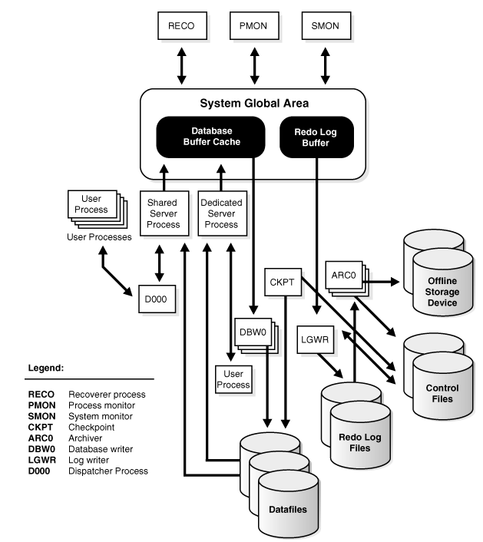

  - Database Writer Process (DBWn)
The database writer process (DBWn) writes the contents of buffers to datafiles. The DBWn processes are responsible for writing modified (dirty) buffers in the database buffer cache to disk. Although one database writer process (DBW0) is adequate for most systems, you can configure additional processes (DBW1 through DBW9 and DBWa through DBWj) to improve write performance if your system modifies data heavily. These additional DBWn processes are not useful on uniprocessor systems.
When a buffer in the database buffer cache is modified, it is marked dirty. A cold buffer is a buffer that has not been recently used according to the least recently used (LRU) algorithm. The DBWn process writes cold, dirty buffers to disk so that user processes are able to find cold, clean buffers that can be used to read new blocks into the cache. As buffers are dirtied by user processes, the number of free buffers diminishes. If the number of free buffers drops too low, user processes that must read blocks from disk into the cache are not able to find free buffers. DBWn manages the buffer cache so that user processes can always find free buffers.
By writing cold, dirty buffers to disk, DBWn improves the performance of finding free buffers while keeping recently used buffers resident in memory. For example, blocks that are part of frequently accessed small tables or indexes are kept in the cache so that they do not need to be read in again from disk. The LRU algorithm keeps more frequently accessed blocks in the buffer cache so that when a buffer is written to disk, it is unlikely to contain data that will be useful soon.
The initialization parameter DB_WRITER_PROCESSES specifies the number of DBWn processes. The maximum number of DBWn processes is 20. If it is not specified by the user during startup, Oracle determines how to set DB_WRITER_PROCESSES based on the number of CPUs and processor groups.
The DBWn process writes dirty buffers to disk under the following conditions:
When a server process cannot find a clean reusable buffer after scanning a threshold number of buffers, it signals DBWn to write. DBWn writes dirty buffers to disk asynchronously while performing other processing.
DBWn periodically writes buffers to advance the checkpoint, which is the position in the redo thread (log) from which instance recovery begins. This log position is determined by the oldest dirty buffer in the buffer cache.
In all cases, DBWn performs batched (multiblock) writes to improve efficiency. The number of blocks written in a multiblock write varies by operating system.

  - Log Writer Process (LGWR)
The log writer process (LGWR) is responsible for redo log buffer management—writing the redo log buffer to a redo log file on disk. LGWR writes all redo entries that have been copied into the buffer since the last time it wrote.The redo log buffer is a circular buffer. When LGWR writes redo entries from the redo log buffer to a redo log file, server processes can then copy new entries over the entries in the redo log buffer that have been written to disk. LGWR normally writes fast enough to ensure that space is always available in the buffer for new entries, even when access to the redo log is heavy.
LGWR writes one contiguous portion of the buffer to disk. LGWR writes:
A commit record when a user process commits a transaction
Redo log buffers
Every three seconds
When the redo log buffer is one-third full
When a DBWn process writes modified buffers to disk, if necessary
LGWR writes synchronously to the active mirrored group of redo log files. If one of the files in the group is damaged or unavailable, LGWR continues writing to other files in the group and logs an error in the LGWR trace file and in the system alert log. If all files in a group are damaged, or the group is unavailable because it has not been archived, LGWR cannot continue to function.
When a user issues a COMMIT statement, LGWR puts a commit record in the redo log buffer and writes it to disk immediately, along with the transaction's redo entries. The corresponding changes to data blocks are deferred until it is more efficient to write them. This is called a fast commit mechanism. The atomic write of the redo entry containing the transaction's commit record is the single event that determines the transaction has committed. Oracle returns a success code to the committing transaction, although the data buffers have not yet been written to disk.
When a user commits a transaction, the transaction is assigned a system change number (SCN), which Oracle records along with the transaction's redo entries in the redo log. SCNs are recorded in the redo log so that recovery operations can be synchronized in Real Application Clusters and distributed databases.
In times of high activity, LGWR can write to the redo log file using group commits. For example, assume that a user commits a transaction. LGWR must write the transaction's redo entries to disk, and as this happens, other users issue COMMIT statements. However, LGWR cannot write to the redo log file to commit these transactions until it has completed its previous write operation. After the first transaction's entries are written to the redo log file, the entire list of redo entries of waiting transactions (not yet committed) can be written to disk in one operation, requiring less I/O than do transaction entries handled individually. Therefore, Oracle minimizes disk I/O and maximizes performance of LGWR. If requests to commit continue at a high rate, then every write (by LGWR) from the redo log buffer can contain multiple commit records.
  - Checkpoint Process (CKPT)
When a checkpoint occurs, Oracle must update the headers of all datafiles to record the details of the checkpoint. This is done by the CKPT process. The CKPT process does not write blocks to disk; DBWn always performs that work.
The statistic DBWR checkpoints displayed by the System_Statistics monitor in Enterprise Manager indicates the number of checkpoint requests completed.
  - System Monitor Process (SMON)
The system monitor process (SMON) performs recovery, if necessary, at instance startup. SMON is also responsible for cleaning up temporary segments that are no longer in use and for coalescing contiguous free extents within dictionary managed tablespaces. If any terminated transactions were skipped during instance recovery because of file-read or offline errors, SMON recovers them when the tablespace or file is brought back online. SMON checks regularly to see whether it is needed. Other processes can call SMON if they detect a need for it.
With Real Application Clusters, the SMON process of one instance can perform instance recovery for a failed CPU or instance.
  - Process Monitor Process (PMON)
The process monitor (PMON) performs process recovery when a user process fails. PMON is responsible for cleaning up the database buffer cache and freeing resources that the user process was using. For example, it resets the status of the active transaction table, releases locks, and removes the process ID from the list of active processes.
PMON periodically checks the status of dispatcher and server processes, and restarts any that have stopped running (but not any that Oracle has terminated intentionally). PMON also registers information about the instance and dispatcher processes with the network listener.
Like SMON, PMON checks regularly to see whether it is needed and can be called if another process detects the need for it.
  - Recoverer Process (RECO)
The recoverer process (RECO) is a background process used with the distributed database configuration that automatically resolves failures involving distributed transactions. The RECO process of a node automatically connects to other databases involved in an in-doubt distributed transaction. When the RECO process reestablishes a connection between involved database servers, it automatically resolves all in-doubt transactions, removing from each database's pending transaction table any rows that correspond to the resolved in-doubt transactions.
If the RECO process fails to connect with a remote server, RECO automatically tries to connect again after a timed interval. However, RECO waits an increasing amount of time (growing exponentially) before it attempts another connection. The RECO process is present only if the instance permits distributed transactions. The number of concurrent distributed transactions is not limited.
  - Job Queue Processes
Job queue processes are used for batch processing. They run user jobs. They can be viewed as a scheduler service that can be used to schedule jobs as PL/SQL statements or procedures on an Oracle instance. Given a start date and an interval, the job queue processes try to run the job at the next occurrence of the interval.
Job queue processes are managed dynamically. This allows job queue clients to use more job queue processes when required. The resources used by the new processes are released when they are idle.
Dynamic job queue processes can run a large number of jobs concurrently at a given interval. The job queue processes run user jobs as they are assigned by the CJQ process. Here's what happens:
The coordinator process, named CJQ0, periodically selects jobs that need to be run from the system JOB$ table. New jobs selected are ordered by time.
The CJQ0 process dynamically spawns job queue slave processes (J000…J999) to run the jobs.
The job queue process runs one of the jobs that was selected by the CJQ process for execution. The processes run one job at a time.
After the process finishes execution of a single job, it polls for more jobs. If no jobs are scheduled for execution, then it enters a sleep state, from which it wakes up at periodic intervals and polls for more jobs. If the process does not find any new jobs, then it aborts after a preset interval.
The initialization parameter JOB_QUEUE_PROCESSES represents the maximum number of job queue processes that can concurrently run on an instance. However, clients should not assume that all job queue processes are available for job execution.
  - Archiver Processes (ARCn)
The archiver process (ARCn) copies redo log files to a designated storage device after a log switch has occurred. ARCn processes are present only when the database is in ARCHIVELOG mode, and automatic archiving is enabled.
An Oracle instance can have up to 10 ARCn processes (ARC0 to ARC9). The LGWR process starts a new ARCn process whenever the current number of ARCn processes is insufficient to handle the workload. The alert log keeps a record of when LGWR starts a new ARCn process.
If you anticipate a heavy workload for archiving, such as during bulk loading of data, you can specify multiple archiver processes with the initialization parameter LOG_ARCHIVE_MAX_PROCESSES. The ALTER SYSTEM statement can change the value of this parameter dynamically to increase or decrease the number of ARCn processes. However, you do not need to change this parameter from its default value of 1, because the system determines how many ARCn processes are needed, and LGWR automatically starts up more ARCn processes when the database workload requires more.
  - Queue Monitor Processes (QMNn)
The queue monitor process is an optional background process for Oracle Streams Advanced Queuing, which monitors the message queues. You can configure up to 10 queue monitor processes. These processes, like the job queue processes, are different from other Oracle background processes in that process failure does not cause the instance to fail.
  - Other Background Processes
There are several other background processes that might be running. These can include the following:
MMON performs various manageability-related background tasks, for example:
Issuing alerts whenever a given metrics violates its threshold value
Taking snapshots by spawning additional process (MMON slaves)
Capturing statistics value for SQL objects which have been recently modified
MMNL performs frequent and light-weight manageability-related tasks, such as session history capture and metrics computation.
MMAN is used for internal database tasks.
RBAL coordinates rebalance activity for disk groups in an Automatic Storage Management instance. It performs a global open on Automatic Storage Management disks.ORBn performs the actual rebalance data extent movements in an Automatic Storage Management instance. There can be many of these at a time, called ORB0, ORB1, and so forth.
OSMB is present in a database instance using an Automatic Storage Management disk group. It communicates with the Automatic Storage Management instance.
  - Trace Files and the Alert Log
Each server and background process can write to an associated trace file. When a process detects an internal error, it dumps information about the error to its trace file. If an internal error occurs and information is written to a trace file, the administrator should contact Oracle Support Services.
All filenames of trace files associated with a background process contain the name of the process that generated the trace file. The one exception to this is trace files generated by job queue processes (Jnnn).
Additional information in trace files can provide guidance for tuning applications or an instance. Background processes always write this information to a trace file when appropriate.
Each database also has an alert.log. The alert log of a database is a chronological log of messages and errors, including the following:
All internal errors (ORA-600), block corruption errors (ORA-1578), and deadlock errors (ORA-60) that occur
Administrative operations, such as the SQL statements CREATE/ALTER/DROP DATABASE/TABLESPACE and the Enterprise Manager or SQL*Plus statements STARTUP, SHUTDOWN, ARCHIVE LOG, and RECOVER
Several messages and errors relating to the functions of shared server and dispatcher processes
Errors during the automatic refresh of a materialized view
Oracle uses the alert log to keep a record of these events as an alternative to displaying the information on an operator's console. (Many systems also display this information on the console.) If an administrative operation is successful, a message is written in the alert log as "completed" along with a time stamp.

  - Physical files
Les The physical files of an Oracle database make it possible to persistently store the data handled by Oracle, while the memory is used to optimize the operating speed of the database.
There are generally two types of files:

• Files used to store database information. All of these files are binary files, which means they cannot be used with a text editor.

• Files intended for the configuration and operation of the Oracle database

Oracle has defined an architecture making it possible to define a standard method of organization of the files of the Oracle database. This architecture is called OFA (Optimal Flexible Architecture).
The files for an Oracle database are as follows:

• Data files (whose extension is .dbf). These files contain all of the database data (tables, views, stored procedures, ...).
• Redo Log files (whose extension is .rdo or .log). These files contain the history of modifications made to the database
• Control files (whose extension is .ctl). These files are used to store information on the state of the database (location of the files, creation dates, etc.)
• The initialization file in editable form init [SID] .ora or the non-editable spfile [SID] .ora file

An Oracle database requires at least one data file, two REDO_LOG files and a control file.
Redo-log files
Redo-log files contain the history of modifications made to the Oracle database. These log files record successive changes to the database so that the database can be restored in the event of a hard drive failure. Thus, if necessary, the Oracle database is able to simulate all the commands that have not been saved in order to restore the content of the database.
Like the data files, the Redo-log files are in an Oracle proprietary format and writing to these files is handled by the LGWR (Log Writer) process.
Oracle also offers an archiving mode allowing the backup of the Redo-log file before its reuse to restore the database. If this mode has not been activated, the content of the Redo Log file is deleted after use.
Finally, these files can be multiplexed (understand duplicated in group directories) in order to provide maximum security.
Control files
Control files are used to store the state of the database. They are created when the database is created.
These files allow, during the initialization of the database, to know if the database has been stopped correctly, as well as to know the location of the data files and the Redo Log files. The control files are themselves identified by the initialization file.
The control file contains the following information:
• Name of the data base
• Date and time of database creation
• The location of the log files (Redo-Log)
• Synchronization information

The initialization file
This file is a text file containing all of the database startup parameters (it is generally named initSID.ora, where SID represents the name given to the instance). However, its existence is not major because it can be easily reconstructed.
A default initialization file is created when creating a database. This is widely documented and examples of values ​​are given for each parameter. However, among these parameters, only a limited number of them are really useful.
It is located in the Oracle home_Directory under dbs
/oracle/……../dbs
C: \ oracle \ ..... \ dbs

- Database managment
  - Environment
To be able to connect to a database from the Linux server, it is essential to validate the environment.
The environment is positioned in the .bash_profile of the "oracle" user:
/home/oracle
Must be setup
Database name ORACLE_SID
Oracle directory ORACLE_HOME
All information must be present into the profile file
[oracle@vm-pris-v-db ~]$ cat .bash_profile
# .bash_profile
# Get the aliases and functions
if [ -f ~/.bashrc ]; then
. ~/.bashrc
fi
# User specific environment and startup programs
ORACLE_HOME=/oracle/app/oracle/product/12.1.0/dbhome_1
export ORACLE_HOME
PATH=$PATH:$HOME/.local/bin:$HOME/bin:$ORACLE_HOME/bin:/home/oracle
export PATH
export ORACLE_SID=PATHTOXV
umask 0002
[oracle@vm-pris-v-db ~]$

  - Standard start
oracle@guy-lx-ora11:/oracle/app/oracle/oradata> sqlplus / as sysdba
SQL*Plus: Release 12.1.0.2.0 Production on Tue Mar 27 14:18:26 2018
Copyright (c) 1982, 2014, Oracle. All rights reserved.
Connected to an idle instance.
SQL> startup;
ORACLE instance started.
Total System Global Area 2801795072 bytes
Fixed Size 2928344 bytes
Variable Size 721420584 bytes
Database Buffers 2063597568 bytes
Redo Buffers 13848576 bytes
Database mounted.
Database opened.
SQL>
  - Standard shutdown
oracle@guy-lx-ora11:/oracle/app/oracle/oradata> sqlplus / as sysdba
SQL*Plus: Release 12.1.0.2.0 Production on Tue Mar 27 14:20:31 2018
Copyright (c) 1982, 2014, Oracle. All rights reserved.
Connected to:
Oracle Database 12c Enterprise Edition Release 12.1.0.2.0 - 64bit Production
With the Partitioning, OLAP, Advanced Analytics and Real Application Testing options
SQL> shutdown [immediate] ; =>
Database closed.
Database dismounted.
ORACLE instance shut down.
SQL>

  - Optional modes
Start with read init file only [ or spfile ]
This file is under $ORACLE_HOME/dbs
oracle@guy-lx-ora11:/oracle/app/oracle/oradata> sqlplus / as sysdba
SQL*Plus: Release 12.1.0.2.0 Production on Tue Mar 27 14:24:15 2018
Copyright (c) 1982, 2014, Oracle. All rights reserved.
Connected to an idle instance.
SQL> startup nomount;
ORACLE instance started.
Total System Global Area 2801795072 bytes
Fixed Size 2928344 bytes
Variable Size 721420584 bytes
Database Buffers 2063597568 bytes
Redo Buffers 13848576 bytes
SQL>

Start with read control files only
SQL> alter database mount;
Database altered.
SQL>

Final openning
SQL> alter database open;
Database altered.
SQL>

Critical stop
SQL> shutdown abort;
ORACLE instance shut down.
SQL>
- Database backup
repository = /ValidationBackup
Example in Full mode (validation server)
rman target /
run {
allocate channel disk1 device type disk format '/ValidationBackup/bk_d%d_u%u_s%s_p%p_t%t';
backup database;
release channel disk1;
sql 'alter system archive log current';
allocate channel disk1 device type disk format '/ValidationBackup/log_d%d_u%u_s%s_p%p_t%t';
backup archivelog all delete input;
release channel disk1;
allocate channel disk1 device type disk format '/ValidationBackup/ctrl_d%d_u%u_s%s_p%p_t%t';
backup current controlfile;
release channel disk1;
}
Log example
Recovery Manager: Release 12.1.0.2.0 - Production on Tue Mar 27 14:02:14 2018
Copyright (c) 1982, 2014, Oracle and/or its affiliates. All rights reserved.
connected to target database: BASE1 (DBID=981225167)
RMAN> 2> 3> 4> 5> 6> 7> 8> 9> 10> 11> 12> 13> 14> 15>
using target database control file instead of recovery catalog
allocated channel: disk1
channel disk1: SID=29 device type=DISK
Starting backup at 27-MAR-18
channel disk1: starting full datafile backup set
channel disk1: specifying datafile(s) in backup set ………
……………………
- Database recover
  - Partial ( datafile lost or corrupted)
    - Datafile remove (
./rollback
./rollback/rbsegment
./rollback/rbsegment/pathtoxundo.dbf
./rollback/archive
./rollback/archive/PATHTOX106986078800010000000011.ARC
./rollback/archive/PATHTOX106986078800010000000012.ARC
./rollback/redologs
./rollback/redologs/pathtox0101.rdl
…….
./rollback/redologs/pathtox1501.rdl
./admin
./admin/PATHTOX01.ctl
./admin/PATHTOX02.ctl
./data
./data/ptscoresys.dbf
./data/ptsanimaldata01.dbf
./data/ptsclinpathdata01.dbf
./data/ptsnecropdata01.dbf
./data/ptssend.dbf
./data/ptspathdata01.dbf
./data/ptspharmacy01.dbf
./data/ptshcdb.dbf
./index
./index/ptsanimal_idx.ndx
./index/ptscoresys.ndx
./index/ptsclinpath_idx.ndx
./index/ptsnecropsy_idx.ndx
./index/ptspathology_idx.ndx
./index/ptspharmacy_idx.ndx
./index/ptshcdb_idx.ndx
./index/ptssend_idx.ndx
./system
./system/pathtoxsy01.dbf
./system/ptssysaux01.dbf
./temporary
./temporary/ptssessmtx.dbf
./temporary/ptshcdb_output.dbf
./temporary/ptssend_output.dbf
./temporary/pathtoxtmp01.dbf
./reporting
./reporting/ptsreports01.dbf
./reporting/ptssbmdata01.dbf
rm/mv pathtoxsy01.dbf [sys.sav]
use ‘mv’ ( move for Windows) instead of ‘rm’ to keep the file

    - Controle of the state of the database
oracle@guy-lx-ora11:/oracle/app/oracle/oradata/BASE1> sqlplus / as sysdba
SQL*Plus: Release 12.1.0.2.0 Production on Tue Mar 27 13:30:58 2018
Copyright (c) 1982, 2014, Oracle. All rights reserved.
Connected to:
Oracle Database 12c Enterprise Edition Release 12.1.0.2.0 - 64bit Production
With the Partitioning, OLAP, Advanced Analytics and Real Application Testing options
SQL> shutdown immediate
ORA-01116: error in opening database file 1
ORA-01110: data file 1: '/oracle/database/PATHTOXV/system/pathtoxsy01.dbf’
ORA-27041: unable to open file
Linux-x86_64 Error: 2: No such file or directory
Additional information: 3
SQL> shutdown abort
ORACLE instance shut down.
SQL>
    - Preparing the database for restoration
SQL> startup mount;
ORACLE instance started.
Total System Global Area 2801795072 bytes
Fixed Size 2928344 bytes
Variable Size 721420584 bytes
Database Buffers 2063597568 bytes
Redo Buffers 13848576 bytes
Database mounted.
SQL>
    - Datafile restore and recover
rman target /
RMAN> run {
3> restore datafile '/oracle/database/PATHTOXV/system/pathtoxsy01.dbf’;
4> recover database;
5> }
using target database control file instead of recovery catalog
allocated channel: disk1
channel disk1: SID=12 device type=DISK
Starting restore at 27-MAR-18
channel disk1: starting datafile backup set restore
channel disk1: specifying datafile(s) to restore from backup set
channel disk1: restoring datafile 00001 to /oracle/app/oracle/oradata/BASE1/system01.dbf
channel disk1: reading from backup piece /mntpoint/bk_dBASE1_u3dsur903_s109_p1_t971875331
channel disk1: piece handle=/sauve/bk_dBASE1_u3dsur903_s109_p1_t971875331 tag=TAG20180327T132211
channel disk1: restored backup piece 1
channel disk1: restore complete, elapsed time: 00:00:07
Finished restore at 27-MAR-18
Starting recover at 27-MAR-18
starting media recovery
media recovery complete, elapsed time: 00:00:01
Finished recover at 27-MAR-18
released channel: disk1

Ouverture de la base
RMAN> alter database open;
Statement processed
RMAN>

  - FULL ( database lost )
Warning
RMAN does not recreate the tree structure during the restore, each directory must be present with write rights for the "oracle" user
    - Preparation (simulation)
Stop the database end remove database home
oracle@guy-lx-ora11:/oracle/app/oracle/oradata/BASE1> sqlplus / as sysdba
SQL*Plus: Release 12.1.0.2.0 Production on Tue Mar 27 13:38:28 2018
Copyright (c) 1982, 2014, Oracle. All rights reserved.
Connected to:
Oracle Database 12c Enterprise Edition Release 12.1.0.2.0 - 64bit Production
With the Partitioning, OLAP, Advanced Analytics and Real Application Testing options
SQL> shutdown immediate
Database closed.
Database dismounted.
ORACLE instance shut down.
SQL> exit
    - Directories creation
[oracle@vm-pom-pris-v-db PATHTOXV]$ ll
total 16
drwxrwxr-x. 2 oracle dba 72 Oct 26 09:28 admin
drwxrwxr-x. 2 oracle dba 199 Oct 26 09:39 data
drwxrwxr-x. 2 oracle dba 61 Oct 26 10:11 export
drwxrwxr-x. 2 oracle dba 4096 May 25 2020 icons
drwxrwxr-x. 2 oracle dba 208 Oct 26 09:39 index
drwxrwxr-x. 2 oracle dba 54 Oct 26 09:39 reporting
drwxrwxr-x. 5 oracle dba 54 May 25 2020 rollback (and subdirectories)
Caution, some others directories under this directory
drwxrwxr-x. 2 oracle dba 8192 Oct 26 10:45 scripts
drwxrwxr-x. 2 oracle dba 52 Oct 26 09:28 system
drwxrwxr-x. 2 oracle dba 104 Oct 26 09:39 temporary
drwxrwxr-x. 2 oracle dba 168 Oct 26 10:42 trace
[oracle@vm-pom-pris-v-db PATHTOXV]$

    - Restoration
Step 1 / Contrôle file restore
Connexion : sqlplus / as sysdba
SQL > Startup nomount ;
oracle@guy-lx-ora11:/oracle/app/oracle/oradata/BASE1> rman target /
RMAN> run {
2> restore controlfile from ‘/ValidationBackup/ctrl_dFORM1_u3fsur91s_s111_p1_t971875388';
!!! Attention, the exact name of the last Backup of the controfile is imperative. Because it is the repository for backups. RMAN cannot find the file itself !!
3> }
Starting restore at 27-MAR-18
using channel ORA_DISK_1
channel ORA_DISK_1: restoring control file
channel ORA_DISK_1: restore complete, elapsed time: 00:00:01
output file name=/oracle/app/oracle/oradata/BASE1/control01.ctl
output file name=/oracle/app/oracle/oradata/BASE1/control02.ctl
Finished restore at 27-MAR-18
RMAN>

Step 2 / Database openning
RMAN> alter database mount;
Statement processed
released channel: ORA_DISK_1

Step 3 / Database restore
RMAN> run {
2> restore database;
3> }
Starting restore at 27-MAR-18
allocated channel: ORA_DISK_1
channel ORA_DISK_1: SID=12 device type=DISK
channel ORA_DISK_1: starting datafile backup set restore
channel ORA_DISK_1: specifying datafile(s) to restore from backup set
channel ORA_DISK_1: restoring datafile 00001 to /oracle/app/oracle/oradata/BASE1/system01.dbf
channel ORA_DISK_1: restoring datafile 00003 to /oracle/app/oracle/oradata/BASE1/sysaux01.dbf
channel ORA_DISK_1: restoring datafile 00004 to /oracle/app/oracle/oradata/BASE1/undotbs01.dbf
channel ORA_DISK_1: restoring datafile 00006 to /oracle/app/oracle/oradata/BASE1/users01.dbf
channel ORA_DISK_1: reading from backup piece /mntpoint/bk_dBASE1_u3dsur903_s109_p1_t971875331
channel ORA_DISK_1: piece handle=/mntpoint/bk_dBASE1_u3dsur903_s109_p1_t971875331 tag=TAG20180327T132211
channel ORA_DISK_1: restored backup piece 1
channel ORA_DISK_1: restore complete, elapsed time: 00:00:25
Finished restore at 27-MAR-18
RMAN>

Step 4 / Database recover (normal error at the end)
RMAN> recover database;
Starting recover at 27-MAR-18
using channel ORA_DISK_1
starting media recovery
channel ORA_DISK_1: starting archived log restore to default destination
channel ORA_DISK_1: restoring archived log
archived log thread=1 sequence=221
channel ORA_DISK_1: restoring archived log
archived log thread=1 sequence=222
channel ORA_DISK_1: reading from backup piece /mntpoint/log_dBASE1_u3ksurbcd_s116_p1_t971877773
channel ORA_DISK_1: piece handle=/mntpoint/log_dBASE1_u3ksurbcd_s116_p1_t971877773 tag=TAG20180327T140253
channel ORA_DISK_1: restored backup piece 1
channel ORA_DISK_1: restore complete, elapsed time: 00:00:01
archived log file name=/vgsave/arch/1_221_964603793.dbf thread=1 sequence=221
archived log file name=/vgsave/arch/1_222_964603793.dbf thread=1 sequence=222
unable to find archived log ( This is not an error )
archived log thread=1 sequence=223
RMAN-00571: ========================================================
RMAN-00569: =============== ERROR MESSAGE STACK FOLLOWS ===============
RMAN-00571: ========================================================
RMAN-03002: failure of recover command at 03/27/2018 14:11:16
RMAN-06054: media recovery requesting unknown archived log for thread 1 with sequence 223 and starting SCN of 4459844
Step 5 / Database open with new redologs
RMAN> alter database open resetlogs;
Statement processed
RMAN>
Remarks
oracle@guy-lx-ora11:/oracle/app/oracle/oradata> sqlplus / as sysdba
SQL*Plus: Release 12.1.0.2.0 Production on Tue Mar 27 14:15:10 2018
Copyright (c) 1982, 2014, Oracle. All rights reserved.
Connected to:
Oracle Database 12c Enterprise Edition Release 12.1.0.2.0 - 64bit Production
With the Partitioning, OLAP, Advanced Analytics and Real Application Testing options
SQL> archive log list;
Database log mode Archive Mode
Automatic archival Enabled
Archive destination /vgsave/arch
Oldest online log sequence 1
Next log sequence to archive 1
Current log sequence 1
SQL>
The old backup files are no longer consistent with the current conf. If the base starts again in production, it is better to delete them.
  - P.I.T Database restoration
    - Preparation
Perform table updates, archive backups (5 minutes between each)
FULL save before modification
Modify table with addition of lines (enter the correct server time)
ARCH backup
Modify table with addition of lines (enter the correct server time)
ARCH backup
And so on

Example
oracle@guy-lx-ora11:/oracle/app/oracle/oradata> sqlplus / as sysdba
SQL*Plus: Release 12.1.0.2.0 Production on Tue Mar 27 14:37:12 2018
Copyright (c) 1982, 2014, Oracle. All rights reserved.
Connected to:
Oracle Database 12c Enterprise Edition Release 12.1.0.2.0 - 64bit Production
With the Partitioning, OLAP, Advanced Analytics and Real Application Testing options
SQL> create table T1 (nmr_client number(10) NOT NULL,
2 nom_client varchar2(50) NOT NULL,
3 ville varchar2(50) NOT NULL,
4 date_modif varchar2(50) NOT NULL);
Table created.
SQL> insert into T1
2 (nmr_client, nom_client, ville, date_modif)
3 values
4 (123, 'HPE', 'PARIS', '27 Mars 2018 1442');
1 row created.
SQL> commit;
Commit complete.
SQL>

Script for archives only
guy-lx-ora11:/exploit # cat sav_rman_arch.sh
export ORACLE_SID=BASE1
rman target / <<EOF
run {
sql 'alter system archive log current';
allocate channel disk1 device type disk format '/ValidationBackup/log_d%d_u%u_s%s_p%p_t%t';
release channel disk1;
allocate channel disk1 device type disk format '/ValidationBackup/ctrl_d%d_u%u_s%s_p%p_t%t';
backup current controlfile;
release channel disk1;
}
EOF

List table entries
oracle@guy-lx-ora11:/oracle/app/oracle/oradata> sqlplus / as sysdba
SQL*Plus: Release 12.1.0.2.0 Production on Tue Mar 27 16:14:20 2018
Copyright (c) 1982, 2014, Oracle. All rights reserved.
Connected to:
Oracle Database 12c Enterprise Edition Release 12.1.0.2.0 - 64bit Production
With the Partitioning, OLAP, Advanced Analytics and Real Application Testing options
SQL> select date_modif from t1;
DATE_MODIF
--------------------------------------------------
27 Mars 2018 1442
27 Mars 2018 1454
27 Mars 2018 1455
27 Mars 2018 1502
27 Mars 2018 1615
SQL>

    - Restoration
Example 15h30
Step 1 / Database stop
Step 2 / Creation of a new set of directories
[oracle@vm-pom-pris-v-db ~]$ cd /oracle/database
[oracle@vm-pom-pris-v-db database]$ ls
PATHTOXV
[oracle@vm-pom-pris-v-db database]$ cd PATHTOXV/
[oracle@vm-pom-pris-v-db PATHTOXV]$ ll
total 16
drwxrwxr-x. 2 oracle dba 72 Oct 26 09:28 admin
drwxrwxr-x. 2 oracle dba 199 Oct 26 09:39 data
drwxrwxr-x. 2 oracle dba 61 Oct 26 10:11 export
drwxrwxr-x. 2 oracle dba 4096 May 25 2020 icons
drwxrwxr-x. 2 oracle dba 208 Oct 26 09:39 index
drwxrwxr-x. 2 oracle dba 54 Oct 26 09:39 reporting
drwxrwxr-x. 5 oracle dba 54 May 25 2020 rollback (and subdirectories)
Caution, some others directories under this directory
drwxrwxr-x. 2 oracle dba 8192 Oct 26 10:45 scripts
drwxrwxr-x. 2 oracle dba 52 Oct 26 09:28 system
drwxrwxr-x. 2 oracle dba 104 Oct 26 09:39 temporary
drwxrwxr-x. 2 oracle dba 168 Oct 26 10:42 trace
[oracle@vm-pom-pris-v-db PATHTOXV]$

Phase 3 / Restauration des controlfiles
!! Use the last backup controlfile !!
oracle@guy-lx-ora11:/oracle/app/oracle/oradata> ls -lrt /ValidationBackup
total 1651760
……..
-rw-r----- 1 oracle users 10125312 Mar 27 14:59 ctrl_dBASE1_u47surenb_s135_p1_t971881195
-rw-r----- 1 oracle users 2256896 Mar 27 15:03 log_dBASE1_u48suretf_s136_p1_t971881391
-rw-r----- 1 oracle users 10125312 Mar 27 15:03 ctrl_dBASE1_u49suretg_s137_p1_t971881392
-rw-r----- 1 oracle users 2996224 Mar 27 16:14 log_dBASE1_u4asurj2g_s138_p1_t971885648
-rw-r----- 1 oracle users 10190848 Mar 27 16:14 ctrl_dBASE1_u4bsurj2h_s139_p1_t971885649
Step 4 / Database Restore ( at the last backup version)
SQL> startup nomount;
ORACLE instance started.
Total System Global Area 2801795072 bytes
Fixed Size 2928344 bytes
Variable Size 721420584 bytes
Database Buffers 2063597568 bytes
Redo Buffers 13848576 bytes
SQL> exit
Disconnected from Oracle Database 12c Enterprise Edition Release 12.1.0.2.0 - 64bit Production
With the Partitioning, OLAP, Advanced Analytics and Real Application Testing options
oracle@guy-lx-ora11:/oracle/app/oracle/oradata> rman target /
Recovery Manager: Release 12.1.0.2.0 - Production on Tue Mar 27 16:19:02 2018
Copyright (c) 1982, 2014, Oracle and/or its affiliates. All rights reserved.
connected to target database: BASE1 (not mounted)
RMAN> run {
2> restore controlfile from '/ValidationBackup/ctrl_dBASE1_u4bsurj2h_s139_p1_t971885649';
3> }

Starting restore at 27-MAR-18
using target database control file instead of recovery catalog
allocated channel: ORA_DISK_1
channel ORA_DISK_1: SID=248 device type=DISK
channel ORA_DISK_1: restoring control file
channel ORA_DISK_1: restore complete, elapsed time: 00:00:01
output file name=/oracle/app/oracle/oradata/BASE1/control01.ctl
output file name=/oracle/app/oracle/oradata/BASE1/control02.ctl
Finished restore at 27-MAR-18

Phase 5 / Database mount
RMAN> alter database mount;
Statement processed
released channel: ORA_DISK_1

Phase 6 / Database restore
RMAN> run {
2> set until time = "to_date('27/03/2018 15:30:00', 'DD/MM/YYYY HH24:MI:SS')";
3>restore database; [ be careful, if no info last Backup used]
Specify the file to use allocate channel disk1 device type disk format '/ValidationBackup/…
The requested restore must be compatible with the desired recover time
4> }
Starting restore at 27-MAR-18
allocated channel: ORA_DISK_1
channel ORA_DISK_1: SID=12 device type=DISK
channel ORA_DISK_1: starting datafile backup set restore
channel ORA_DISK_1: specifying datafile(s) to restore from backup set
channel ORA_DISK_1: restoring datafile 00001 to /oracle/app/oracle/oradata/BASE1/system01.dbf
channel ORA_DISK_1: restoring datafile 00003 to /oracle/app/oracle/oradata/BASE1/sysaux01.dbf
channel ORA_DISK_1: restoring datafile 00004 to /oracle/app/oracle/oradata/BASE1/undotbs01.dbf
channel ORA_DISK_1: restoring datafile 00006 to /oracle/app/oracle/oradata/BASE1/users01.dbf
channel ORA_DISK_1: reading from backup piece /sauve/bk_dBASE1_u3osurd13_s120_p1_t971879459
channel ORA_DISK_1: piece handle=/sauve/bk_dBASE1_u3osurd13_s120_p1_t971879459 tag=TAG20180327T143059
channel ORA_DISK_1: restored backup piece 1
channel ORA_DISK_1: restore complete, elapsed time: 00:00:25
Finished restore at 27-MAR-18

Phase 7 / Recover to a specific time
RMAN> run {
2> set until time = "to_date('27/03/2018 15:30:00', 'DD/MM/YYYY HH24:MI:SS')";
3> recover database;
4> }
executing command: SET until clause
Starting recover at 27-MAR-18
using channel ORA_DISK_1
starting media recovery
channel ORA_DISK_1: starting archived log restore to default destination
channel ORA_DISK_1: restoring archived log
archived log thread=1 sequence=2
channel ORA_DISK_1: restoring archived log
archived log thread=1 sequence=3
channel ORA_DISK_1: reading from backup piece /sauve/log_dBASE1_u3qsurd2j_s122_p1_t971879507
channel ORA_DISK_1: piece handle=/sauve/log_dBASE1_u3qsurd2j_s122_p1_t971879507 tag=TAG20180327T143147
channel ORA_DISK_1: restored backup piece 1
channel ORA_DISK_1: restore complete, elapsed time: 00:00:01
archived log file name=/vgsave/arch/1_2_971878307.dbf thread=1 sequence=2
archived log file name=/vgsave/arch/1_3_971878307.dbf thread=1 sequence=3
channel ORA_DISK_1: starting archived log restore to default destination
channel ORA_DISK_1: restoring archived log
archived log thread=1 sequence=4
channel ORA_DISK_1: restoring archived log
archived log thread=1 sequence=5
channel ORA_DISK_1: reading from backup piece /sauve/log_dBASE1_u3usurdq3_s126_p1_t971880259
channel ORA_DISK_1: piece handle=/sauve/log_dBASE1_u3usurdq3_s126_p1_t971880259 tag=TAG20180327T144419
channel ORA_DISK_1: restored backup piece 1
channel ORA_DISK_1: restore complete, elapsed time: 00:00:01
archived log file name=/vgsave/arch/1_4_971878307.dbf thread=1 sequence=4
archived log file name=/vgsave/arch/1_5_971878307.dbf thread=1 sequence=5
channel ORA_DISK_1: starting archived log restore to default destination
channel ORA_DISK_1: restoring archived log
archived log thread=1 sequence=6
channel ORA_DISK_1: restoring archived log
archived log thread=1 sequence=7
channel ORA_DISK_1: reading from backup piece /sauve/log_dBASE1_u40sure75_s128_p1_t971880677
channel ORA_DISK_1: piece handle=/sauve/log_dBASE1_u40sure75_s128_p1_t971880677 tag=TAG20180327T145116
channel ORA_DISK_1: restored backup piece 1
channel ORA_DISK_1: restore complete, elapsed time: 00:00:01
archived log file name=/vgsave/arch/1_6_971878307.dbf thread=1 sequence=6
archived log file name=/vgsave/arch/1_7_971878307.dbf thread=1 sequence=7
channel ORA_DISK_1: starting archived log restore to default destination
channel ORA_DISK_1: restoring archived log
archived log thread=1 sequence=8
channel ORA_DISK_1: restoring archived log
archived log thread=1 sequence=9
channel ORA_DISK_1: reading from backup piece /sauve/log_dBASE1_u42sure9p_s130_p1_t971880761
channel ORA_DISK_1: piece handle=/sauve/log_dBASE1_u42sure9p_s130_p1_t971880761 tag=TAG20180327T145241
channel ORA_DISK_1: restored backup piece 1
channel ORA_DISK_1: restore complete, elapsed time: 00:00:01
archived log file name=/vgsave/arch/1_8_971878307.dbf thread=1 sequence=8
archived log file name=/vgsave/arch/1_9_971878307.dbf thread=1 sequence=9
channel ORA_DISK_1: starting archived log restore to default destination
channel ORA_DISK_1: restoring archived log
archived log thread=1 sequence=10
channel ORA_DISK_1: restoring archived log
archived log thread=1 sequence=11
channel ORA_DISK_1: reading from backup piece /sauve/log_dBASE1_u44surea3_s132_p1_t971880771
channel ORA_DISK_1: piece handle=/sauve/log_dBASE1_u44surea3_s132_p1_t971880771 tag=TAG20180327T145251
channel ORA_DISK_1: restored backup piece 1
channel ORA_DISK_1: restore complete, elapsed time: 00:00:01
archived log file name=/vgsave/arch/1_10_971878307.dbf thread=1 sequence=10
archived log file name=/vgsave/arch/1_11_971878307.dbf thread=1 sequence=11
channel ORA_DISK_1: starting archived log restore to default destination
channel ORA_DISK_1: restoring archived log
archived log thread=1 sequence=12
channel ORA_DISK_1: restoring archived log
archived log thread=1 sequence=13
channel ORA_DISK_1: reading from backup piece /sauve/log_dBASE1_u46surena_s134_p1_t971881194
channel ORA_DISK_1: piece handle=/sauve/log_dBASE1_u46surena_s134_p1_t971881194 tag=TAG20180327T145954
channel ORA_DISK_1: restored backup piece 1
channel ORA_DISK_1: restore complete, elapsed time: 00:00:01
archived log file name=/vgsave/arch/1_12_971878307.dbf thread=1 sequence=12
archived log file name=/vgsave/arch/1_13_971878307.dbf thread=1 sequence=13
channel ORA_DISK_1: starting archived log restore to default destination
channel ORA_DISK_1: restoring archived log
archived log thread=1 sequence=14
channel ORA_DISK_1: restoring archived log
archived log thread=1 sequence=15
channel ORA_DISK_1: reading from backup piece /sauve/log_dBASE1_u48suretf_s136_p1_t971881391
channel ORA_DISK_1: piece handle=/sauve/log_dBASE1_u48suretf_s136_p1_t971881391 tag=TAG20180327T150311
channel ORA_DISK_1: restored backup piece 1
channel ORA_DISK_1: restore complete, elapsed time: 00:00:01
archived log file name=/vgsave/arch/1_14_971878307.dbf thread=1 sequence=14
archived log file name=/vgsave/arch/1_15_971878307.dbf thread=1 sequence=15
channel ORA_DISK_1: starting archived log restore to default destination
channel ORA_DISK_1: restoring archived log
archived log thread=1 sequence=16
channel ORA_DISK_1: reading from backup piece /mntpoint/log_dBASE1_u4asurj2g_s138_p1_t971885648
channel ORA_DISK_1: piece handle=/sauve/log_dBASE1_u4asurj2g_s138_p1_t971885648 tag=TAG20180327T161407
channel ORA_DISK_1: restored backup piece 1
channel ORA_DISK_1: restore complete, elapsed time: 00:00:01
archived log file name=/vgsave/arch/1_16_971878307.dbf thread=1 sequence=16
media recovery complete, elapsed time: 00:00:00
Finished recover at 27-MAR-18

Phase 8 / Database open after reset logs
RMAN>
RMAN> alter database open resetlogs;
Statement processed
RMAN> exit
Recovery Manager complete.

Check Table T1
oracle@guy-lx-ora11:/oracle/app/oracle/oradata> sqlplus / as sysdba
SQL*Plus: Release 12.1.0.2.0 Production on Tue Mar 27 16:24:46 2018
Copyright (c) 1982, 2014, Oracle. All rights reserved.
Connected to:
Oracle Database 12c Enterprise Edition Release 12.1.0.2.0 - 64bit Production
With the Partitioning, OLAP, Advanced Analytics and Real Application Testing options
SQL> select date_modif from t1;
DATE_MODIF
--------------------------------------------------
27 Mars 2018 1442
27 Mars 2018 1454
27 Mars 2018 1455
27 Mars 2018 1502
SQL>

  - RMAN retention
new RMAN configuration parameters:
rman target /
RMAN> CONFIGURE RETENTION POLICY TO RECOVERY WINDOW OF 7 DAYS;
new RMAN configuration parameters are successfully stored
RMAN> show all;
RMAN configuration parameters for database with db_unique_name FORM2 are:
CONFIGURE RETENTION POLICY TO RECOVERY WINDOW OF 7 DAYS;
CONFIGURE BACKUP OPTIMIZATION OFF; # default
……….
CONFIGURE ARCHIVELOG DELETION POLICY TO NONE; # default
CONFIGURE SNAPSHOT CONTROLFILE NAME TO '/oracle/app/oracle/product/12.1.0/dbhome_1/dbs/snapcf_FORM2.f'; # default
RMAN>

  - Backup files managment
!! To be completed !!

- ERBC scripts
Main menu
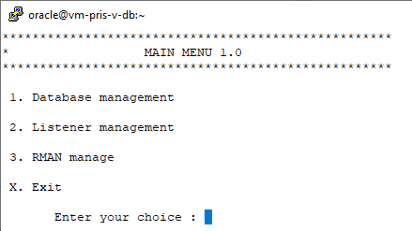

Choise 1 database management

Choise 2 Listener managment
Choise 3 Backup/Restore managment

  - Database management
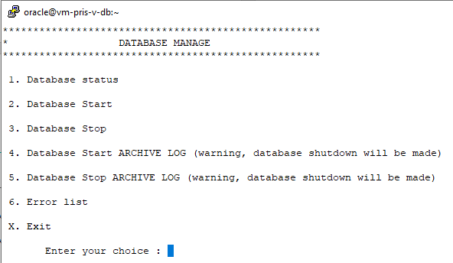

    - Database status
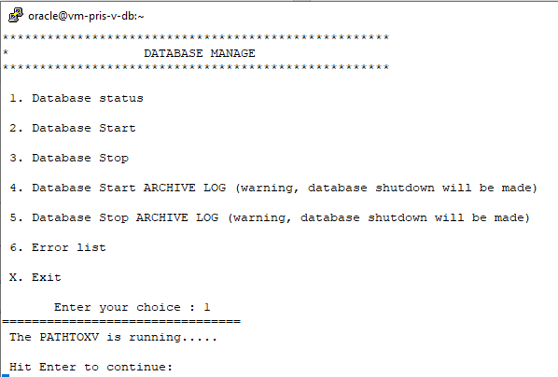
Database is running or not….

    - Database Stop/Start
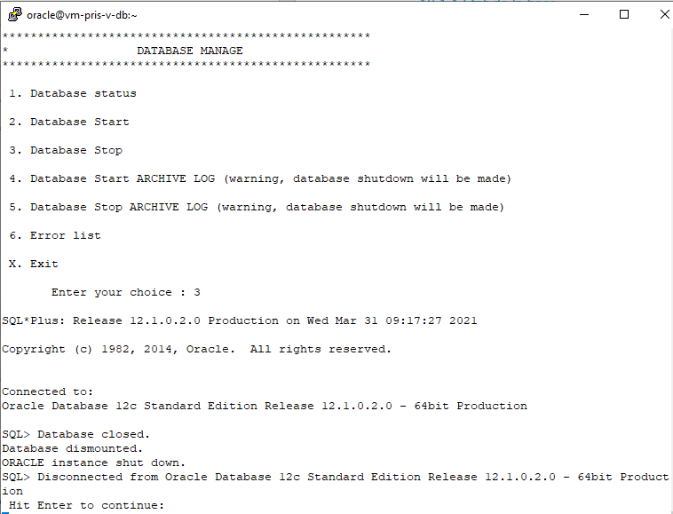

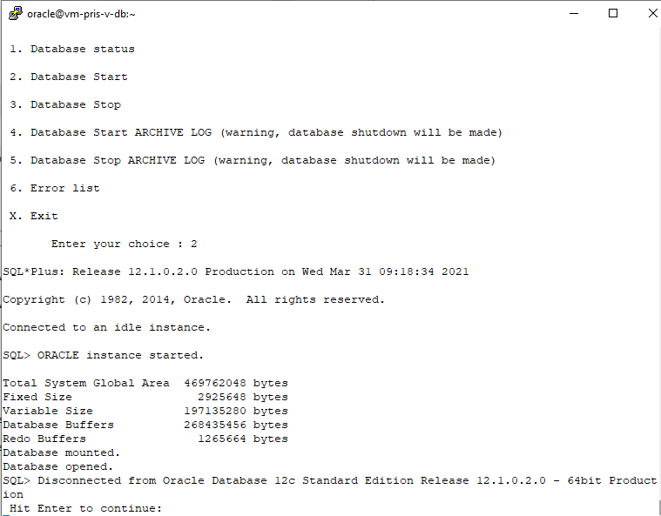

    - Gestion mode archive log
For the correct backup of the database, it is configured in archive log mode. However, for loading operations (import, etc.), it is desirable to put the database back in “no archive log” mode. This makes it possible to avoid a large number of logs and not to slow down the import operation for example
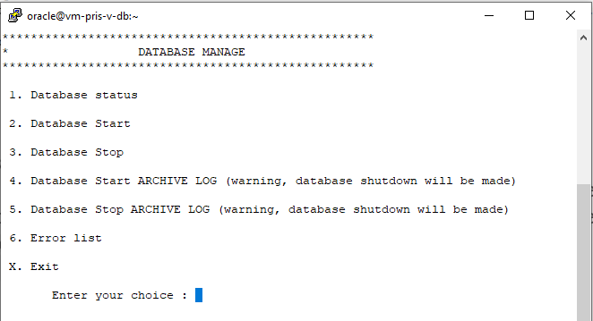
Be careful, changing the mode causes a basic stop
  - Listener managment
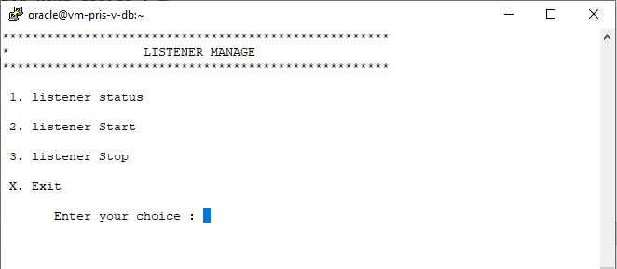
Choise 1 Listener Status
Choise 2 Listerner Start
Choise 3 Listener Stop

Example : Is the listener running ?
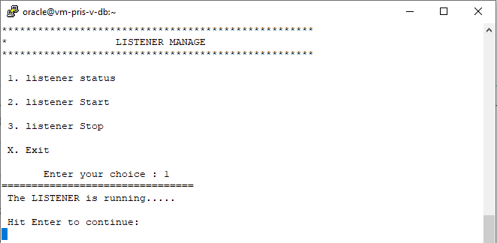

  - RMAN management
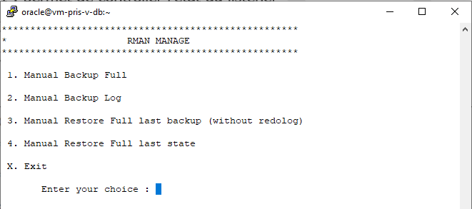
Choise 1 Allows to perform a FULL backup of the database
Choise 2 Allows to perform a LOG backup
Choise 3 Allows to perform a FULL restore.
This option should be used when a complete or significant destruction is detected, or if data has been modified and a rollback is required.
Please note, this does not replace the protocol described in this documentation for PIT restoration
In this option, if the redo logs files are present, they will be deleted. The database will be put back online on the date of the last backup.

Choise 4 Allows to perform a Partial restore
This option should be used when a physical element of the database has been destroyed or corrupted, but the control_files and redologs files are still present.
The database will be put back online on the date of the last validated modification.

- RMAN commands
  - Archive mode ?
[oracle@formora2 ~]$ sqlplus / as sysdba
SQL*Plus: Release 12.1.0.2.0 Production on Thu Apr 19 09:15:45 2018
Copyright (c) 1982, 2014, Oracle. All rights reserved.
Connected to:
Oracle Database 12c Enterprise Edition Release 12.1.0.2.0 - 64bit Production
With the Partitioning, OLAP, Advanced Analytics and Real Application Testing options
SQL> archive log list;
Database log mode Archive Mode
Automatic archival Enabled
Archive destination /base/arch
Oldest online log sequence 10
Next log sequence to archive 12
Current log sequence 12
SQL>
  - RMAN commands
[oracle@formora2 ~]$ rman target /
Recovery Manager: Release 12.1.0.2.0 - Production on Thu Apr 19 09:17:41 2018
Copyright (c) 1982, 2014, Oracle and/or its affiliates. All rights reserved.
connected to target database: PATHTOXV (DBID=4009274280)
    - List of parameters
RMAN> show all;
using target database control file instead of recovery catalog
RMAN configuration parameters for database with db_unique_name PATHTOXV are:
CONFIGURE RETENTION POLICY TO RECOVERY WINDOW OF 7 DAYS;
CONFIGURE BACKUP OPTIMIZATION OFF; # default
CONFIGURE DEFAULT DEVICE TYPE TO DISK; # default
CONFIGURE CONTROLFILE AUTOBACKUP OFF; # default
CONFIGURE CONTROLFILE AUTOBACKUP FORMAT FOR DEVICE TYPE DISK TO '%F'; # default
CONFIGURE DEVICE TYPE DISK PARALLELISM 1 BACKUP TYPE TO BACKUPSET; # default
CONFIGURE DATAFILE BACKUP COPIES FOR DEVICE TYPE DISK TO 1; # default
CONFIGURE ARCHIVELOG BACKUP COPIES FOR DEVICE TYPE DISK TO 1; # default
CONFIGURE MAXSETSIZE TO UNLIMITED; # default
CONFIGURE ENCRYPTION FOR DATABASE OFF; # default
CONFIGURE ENCRYPTION ALGORITHM 'AES128'; # default
CONFIGURE COMPRESSION ALGORITHM 'BASIC' AS OF RELEASE 'DEFAULT' OPTIMIZE FOR LOAD TRUE ; # default
CONFIGURE RMAN OUTPUT TO KEEP FOR 7 DAYS; # default
CONFIGURE ARCHIVELOG DELETION POLICY TO NONE; # default
CONFIGURE SNAPSHOT CONTROLFILE NAME TO '/oracle/app/oracle/product/12.1.0/dbhome_1/dbs/snapcf_PATHTOXV.f'; # default
RMAN>

    - List of backups
RMAN> list backup summary;

List of Backups
===============
Key TY LV S Device Type Completion Time #Pieces #Copies Compressed Tag
------- -- -- - ----------- --------------- ------- ------- ---------- ---
1 B F A DISK 30-MAR-21 1 1 NO TAG20210330T151901
2 B F A DISK 30-MAR-21 1 1 NO TAG20210330T151901
3 B A A DISK 30-MAR-21 1 1 NO TAG20210330T151950
4 B F A DISK 30-MAR-21 1 1 NO TAG20210330T152416
5 B F A DISK 30-MAR-21 1 1 NO TAG20210330T152416
………………..

    - Synchronisation avec des backup sur disque
RMAN> crosscheck backup;
allocated channel: ORA_DISK_1
channel ORA_DISK_1: SID=59 device type=DISK
crosschecked backup piece: found to be 'EXPIRED'
backup piece handle=/sauve/log_dFORM2_u05t0irq6_s5_p1_t973696838 RECID=4 STAMP=973696838
Crosschecked 1 objects
RMAN>

    - Remove expired backup
RMAN> delete expired backup ;

    - Remove obsolete backup
Example
RMAN> delete obsolete;
RMAN retention policy will be applied to the command
RMAN retention policy is set to recovery window of 7 days
using channel ORA_DISK_1
Deleting the following obsolete backups and copies:
Type Key Completion Time Filename/Handle
-------------------- ------ ------------------ --------------------
Backup Set 1 30-MAR-21
Backup Piece 1 30-MAR-21 /sauve/bk_dPATHTOXV_u01vr1vf5_s1_p1_t1068563941
Backup Set 2 30-MAR-21
Backup Piece 2 30-MAR-21 /sauve/bk_dPATHTOXV_u02vr1vgj_s2_p1_t1068563987
Backup Set 3 30-MAR-21
Backup Piece 3 30-MAR-21 /sauve/log_dPATHTOXV_u03vr1vgm_s3_p1_t1068563990
Backup Set 4 30-MAR-21
Backup Piece 4 30-MAR-21 /sauve/bk_dPATHTOXV_u04vr1vp0_s4_p1_t1068564256
Backup Set 5 30-MAR-21
Backup Piece 5 30-MAR-21 /sauve/bk_dPATHTOXV_u05vr1vq4_s5_p1_t1068564292
Backup Set 6 30-MAR-21
Backup Piece 6 30-MAR-21 /sauve/log_dPATHTOXV_u06vr1vq6_s6_p1_t1068564294
Backup Set 7 30-MAR-21
Backup Piece 7 30-MAR-21 /sauve/ctrl_dPATHTOXV_u07vr1vq7_s7_p1_t1068564295
Backup Set 8 30-MAR-21
Backup Piece 8 30-MAR-21 /sauve/bk_dPATHTOXV_u08vr2215_s8_p1_t1068566565
Backup Set 9 30-MAR-21
Backup Piece 9 30-MAR-21 /sauve/bk_dPATHTOXV_u09vr2229_s9_p1_t1068566601
Backup Set 10 30-MAR-21
Backup Piece 10 30-MAR-21 /sauve/log_dPATHTOXV_u0avr222b_s10_p1_t1068566603
Backup Set 11 30-MAR-21
Backup Piece 11 30-MAR-21 /sauve/bk_dPATHTOXV_u0dvr250p_s13_p1_t1068569625
Backup Set 12 30-MAR-21
Backup Piece 12 30-MAR-21 /sauve/bk_dPATHTOXV_u0evr2526_s14_p1_t1068569670
Backup Set 13 30-MAR-21
Backup Piece 13 30-MAR-21 /sauve/log_dPATHTOXV_u0fvr2529_s15_p1_t1068569673
Backup Set 14 30-MAR-21
Backup Piece 14 30-MAR-21 /sauve/log_dPATHTOXV_u0gvr252a_s16_p1_t1068569674
Backup Set 15 30-MAR-21
Backup Piece 15 30-MAR-21 /sauve/ctrl_dPATHTOXV_u0hvr252c_s17_p1_t1068569676
Backup Set 16 31-MAR-21
Backup Piece 16 31-MAR-21 /sauve/ctrl_dPATHTOXV_u0ivr3u2g_s18_p1_t1068628048
Backup Set 17 31-MAR-21
Backup Piece 17 31-MAR-21 /sauve/bk_dPATHTOXV_u0jvr3u3k_s19_p1_t1068628084
Backup Set 18 31-MAR-21
Backup Piece 18 31-MAR-21 /sauve/bk_dPATHTOXV_u0kvr3u4o_s20_p1_t1068628120
Backup Set 19 31-MAR-21
Backup Piece 19 31-MAR-21 /sauve/log_dPATHTOXV_u0lvr3u4q_s21_p1_t1068628122
Backup Set 20 31-MAR-21
Backup Piece 20 31-MAR-21 /sauve/ctrl_dPATHTOXV_u0mvr3u4u_s22_p1_t1068628126
Backup Set 21 31-MAR-21
Backup Piece 21 31-MAR-21 /sauve/ctrl_dPATHTOXV_u0nvr3u5a_s23_p1_t1068628138
Backup Set 22 31-MAR-21
Backup Piece 22 31-MAR-21 /sauve/bk_dPATHTOXV_u0ovr40cl_s24_p1_t1068630421
Backup Set 23 31-MAR-21
Backup Piece 23 31-MAR-21 /sauve/bk_dPATHTOXV_u0pvr40do_s25_p1_t1068630456
Backup Set 24 31-MAR-21
Backup Piece 24 31-MAR-21 /sauve/log_dPATHTOXV_u0qvr40dr_s26_p1_t1068630459
Backup Set 25 31-MAR-21
Backup Piece 25 31-MAR-21 /sauve/ctrl_dPATHTOXV_u0rvr40ds_s27_p1_t1068630460
Backup Set 26 31-MAR-21
Backup Piece 26 31-MAR-21 /sauve/ctrl_dPATHTOXV_u0svr40i0_s28_p1_t1068630592
Backup Set 27 31-MAR-21
Backup Piece 27 31-MAR-21 /sauve/bk_dPATHTOXV_u0vvr43e7_s31_p1_t1068633543
Backup Set 28 31-MAR-21
Backup Piece 28 31-MAR-21 /sauve/bk_dPATHTOXV_u10vr43fu_s32_p1_t1068633598
Backup Set 29 31-MAR-21
Backup Piece 29 31-MAR-21 /sauve/log_dPATHTOXV_u11vr43g1_s33_p1_t1068633601
Backup Set 30 31-MAR-21
Backup Piece 30 31-MAR-21 /sauve/log_dPATHTOXV_u12vr43g2_s34_p1_t1068633602
Backup Set 31 31-MAR-21
Backup Piece 31 31-MAR-21 /sauve/bk_dPATHTOXV_u15vr4hgv_s37_p1_t1068647967
Backup Set 32 31-MAR-21
Backup Piece 32 31-MAR-21 /sauve/bk_dPATHTOXV_u16vr4hic_s38_p1_t1068648012
Backup Set 33 31-MAR-21
Backup Piece 33 31-MAR-21 /sauve/log_dPATHTOXV_u17vr4hif_s39_p1_t1068648015
Backup Set 34 31-MAR-21
Backup Piece 34 31-MAR-21 /sauve/log_dPATHTOXV_u18vr4hih_s40_p1_t1068648017
Backup Set 35 31-MAR-21
Backup Piece 35 31-MAR-21 /sauve/ctrl_dPATHTOXV_u19vr4hii_s41_p1_t1068648018
Backup Set 36 31-MAR-21
Backup Piece 36 31-MAR-21 /sauve/bk_dPATHTOXV_u1avr4hlv_s42_p1_t1068648127
Backup Set 37 31-MAR-21
Backup Piece 37 31-MAR-21 /sauve/bk_dPATHTOXV_u1bvr4hnd_s43_p1_t1068648173
Backup Set 38 31-MAR-21
Backup Piece 38 31-MAR-21 /sauve/log_dPATHTOXV_u1cvr4hng_s44_p1_t1068648176
Backup Set 39 31-MAR-21
Backup Piece 39 31-MAR-21 /sauve/bk_dPATHTOXV_u1fvr4k3g_s47_p1_t1068650608
Backup Set 40 31-MAR-21
Backup Piece 40 31-MAR-21 /sauve/bk_dPATHTOXV_u1gvr4k4t_s48_p1_t1068650653
Backup Set 41 31-MAR-21
Backup Piece 41 31-MAR-21 /sauve/log_dPATHTOXV_u1hvr4k50_s49_p1_t1068650656
Backup Set 42 31-MAR-21
Backup Piece 42 31-MAR-21 /sauve/log_dPATHTOXV_u1ivr4k51_s50_p1_t1068650657
Backup Set 43 01-APR-21
Backup Piece 43 01-APR-21 /sauve/ctrl_dPATHTOXV_u1lvr7al9_s53_p1_t1068739241
Backup Set 44 01-APR-21
Backup Piece 44 01-APR-21 /sauve/log_dPATHTOXV_u1mvr7asp_s54_p1_t1068739481
Backup Set 45 01-APR-21
Backup Piece 45 01-APR-21 /sauve/log_dPATHTOXV_u1nvr7ass_s55_p1_t1068739484
Backup Set 46 01-APR-21
Backup Piece 46 01-APR-21 /sauve/ctrl_dPATHTOXV_u1ovr7ast_s56_p1_t1068739485
Backup Set 47 06-APR-21
Backup Piece 47 06-APR-21 /sauve/log_dPATHTOXV_u1pvrkgg9_s57_p1_t1069171209
Backup Set 48 06-APR-21
Backup Piece 48 06-APR-21 /sauve/log_dPATHTOXV_u1qvrkggo_s58_p1_t1069171224
Backup Set 49 06-APR-21
Backup Piece 49 06-APR-21 /sauve/ctrl_dPATHTOXV_u1rvrkggq_s59_p1_t1069171226
Backup Set 50 06-APR-21
Backup Piece 50 06-APR-21 /sauve/bk_dPATHTOXV_u1svrkr1o_s60_p1_t1069182008
Backup Set 51 06-APR-21
Backup Piece 51 06-APR-21 /sauve/bk_dPATHTOXV_u1tvrkr2s_s61_p1_t1069182044
Backup Set 52 06-APR-21
Backup Piece 52 06-APR-21 /sauve/log_dPATHTOXV_u1uvrkr2v_s62_p1_t1069182047
Backup Set 53 06-APR-21
Backup Piece 53 06-APR-21 /sauve/log_dPATHTOXV_u1vvrkr3f_s63_p1_t1069182063
Backup Set 54 06-APR-21
Backup Piece 54 06-APR-21 /sauve/ctrl_dPATHTOXV_u20vrkr3g_s64_p1_t1069182064
Backup Set 55 07-APR-21
Backup Piece 55 07-APR-21 /sauve/log_dPATHTOXV_u21vrm8o9_s65_p1_t1069228809
Backup Set 56 07-APR-21
Backup Piece 56 07-APR-21 /sauve/ctrl_dPATHTOXV_u22vrm8oc_s66_p1_t1069228812
Backup Set 57 07-APR-21
Backup Piece 57 07-APR-21 /sauve/log_dPATHTOXV_u23vrmmq8_s67_p1_t1069243208
Backup Set 58 07-APR-21
Backup Piece 58 07-APR-21 /sauve/ctrl_dPATHTOXV_u24vrmmqc_s68_p1_t1069243212
Backup Set 59 07-APR-21
Backup Piece 59 07-APR-21 /sauve/log_dPATHTOXV_u25vrn4s8_s69_p1_t1069257608
Backup Set 60 07-APR-21
Backup Piece 60 07-APR-21 /sauve/ctrl_dPATHTOXV_u26vrn4sb_s70_p1_t1069257611
Backup Set 61 07-APR-21
Backup Piece 61 07-APR-21 /sauve/bk_dPATHTOXV_u27vrnfdo_s71_p1_t1069268408
Backup Set 62 07-APR-21
Backup Piece 62 07-APR-21 /sauve/bk_dPATHTOXV_u28vrnfes_s72_p1_t1069268444
Backup Set 63 07-APR-21
Backup Piece 63 07-APR-21 /sauve/log_dPATHTOXV_u29vrnfeu_s73_p1_t1069268446
Backup Set 64 07-APR-21
Backup Piece 64 07-APR-21 /sauve/ctrl_dPATHTOXV_u2avrnff2_s74_p1_t1069268450
Backup Set 65 08-APR-21
Backup Piece 65 08-APR-21 /sauve/log_dPATHTOXV_u2bvrot49_s75_p1_t1069315209
Backup Set 66 08-APR-21
Backup Piece 66 08-APR-21 /sauve/ctrl_dPATHTOXV_u2cvrot4c_s76_p1_t1069315212
Backup Set 67 08-APR-21
Backup Piece 67 08-APR-21 /sauve/log_dPATHTOXV_u2dvrpb68_s77_p1_t1069329608
Backup Set 68 08-APR-21
Backup Piece 68 08-APR-21 /sauve/ctrl_dPATHTOXV_u2evrpb6c_s78_p1_t1069329612
Backup Set 69 08-APR-21
Backup Piece 69 08-APR-21 /sauve/log_dPATHTOXV_u2fvrpp87_s79_p1_t1069344007
Backup Set 70 08-APR-21
Backup Piece 70 08-APR-21 /sauve/ctrl_dPATHTOXV_u2gvrpp8b_s80_p1_t1069344011
Backup Set 72 08-APR-21
Backup Piece 72 08-APR-21 /sauve/bk_dPATHTOXV_u2ivrq3qr_s82_p1_t1069354843
Backup Set 74 08-APR-21
Backup Piece 74 08-APR-21 /sauve/ctrl_dPATHTOXV_u2kvrq3r1_s84_p1_t1069354849

Do you really want to delete the above objects (enter YES or NO)? YES
deleted backup piece
backup piece handle=/sauve/bk_dPATHTOXV_u01vr1vf5_s1_p1_t1068563941 RECID=1 STAMP=1068563941
deleted backup piece
backup piece handle=/sauve/bk_dPATHTOXV_u02vr1vgj_s2_p1_t1068563987 RECID=2 STAMP=1068563988
deleted backup piece
backup piece handle=/sauve/log_dPATHTOXV_u03vr1vgm_s3_p1_t1068563990 RECID=3 STAMP=1068563990
deleted backup piece
backup piece handle=/sauve/bk_dPATHTOXV_u04vr1vp0_s4_p1_t1068564256 RECID=4 STAMP=1068564256
deleted backup piece
backup piece handle=/sauve/bk_dPATHTOXV_u05vr1vq4_s5_p1_t1068564292 RECID=5 STAMP=1068564293
deleted backup piece
backup piece handle=/sauve/log_dPATHTOXV_u06vr1vq6_s6_p1_t1068564294 RECID=6 STAMP=1068564294
deleted backup piece
backup piece handle=/sauve/ctrl_dPATHTOXV_u07vr1vq7_s7_p1_t1068564295 RECID=7 STAMP=1068564296
deleted backup piece
backup piece handle=/sauve/bk_dPATHTOXV_u08vr2215_s8_p1_t1068566565 RECID=8 STAMP=1068566566
deleted backup piece
backup piece handle=/sauve/bk_dPATHTOXV_u09vr2229_s9_p1_t1068566601 RECID=9 STAMP=1068566602
deleted backup piece
backup piece handle=/sauve/log_dPATHTOXV_u0avr222b_s10_p1_t1068566603 RECID=10 STAMP=1068566603
deleted backup piece
backup piece handle=/sauve/bk_dPATHTOXV_u0dvr250p_s13_p1_t1068569625 RECID=11 STAMP=1068569625
deleted backup piece
backup piece handle=/sauve/bk_dPATHTOXV_u0evr2526_s14_p1_t1068569670 RECID=12 STAMP=1068569671
deleted backup piece
backup piece handle=/sauve/log_dPATHTOXV_u0fvr2529_s15_p1_t1068569673 RECID=13 STAMP=1068569673
deleted backup piece
backup piece handle=/sauve/log_dPATHTOXV_u0gvr252a_s16_p1_t1068569674 RECID=14 STAMP=1068569674
deleted backup piece
backup piece handle=/sauve/ctrl_dPATHTOXV_u0hvr252c_s17_p1_t1068569676 RECID=15 STAMP=1068569677
deleted backup piece
backup piece handle=/sauve/ctrl_dPATHTOXV_u0ivr3u2g_s18_p1_t1068628048 RECID=16 STAMP=1068628049
deleted backup piece
backup piece handle=/sauve/bk_dPATHTOXV_u0jvr3u3k_s19_p1_t1068628084 RECID=17 STAMP=1068628086
deleted backup piece
backup piece handle=/sauve/bk_dPATHTOXV_u0kvr3u4o_s20_p1_t1068628120 RECID=18 STAMP=1068628121
deleted backup piece
backup piece handle=/sauve/log_dPATHTOXV_u0lvr3u4q_s21_p1_t1068628122 RECID=19 STAMP=1068628122
deleted backup piece
backup piece handle=/sauve/ctrl_dPATHTOXV_u0mvr3u4u_s22_p1_t1068628126 RECID=20 STAMP=1068628127
deleted backup piece
backup piece handle=/sauve/ctrl_dPATHTOXV_u0nvr3u5a_s23_p1_t1068628138 RECID=21 STAMP=1068628139
deleted backup piece
backup piece handle=/sauve/bk_dPATHTOXV_u0ovr40cl_s24_p1_t1068630421 RECID=22 STAMP=1068630422
deleted backup piece
backup piece handle=/sauve/bk_dPATHTOXV_u0pvr40do_s25_p1_t1068630456 RECID=23 STAMP=1068630457
deleted backup piece
backup piece handle=/sauve/log_dPATHTOXV_u0qvr40dr_s26_p1_t1068630459 RECID=24 STAMP=1068630459
deleted backup piece
backup piece handle=/sauve/ctrl_dPATHTOXV_u0rvr40ds_s27_p1_t1068630460 RECID=25 STAMP=1068630462
deleted backup piece
backup piece handle=/sauve/ctrl_dPATHTOXV_u0svr40i0_s28_p1_t1068630592 RECID=26 STAMP=1068630593
deleted backup piece
backup piece handle=/sauve/bk_dPATHTOXV_u0vvr43e7_s31_p1_t1068633543 RECID=27 STAMP=1068633543
deleted backup piece
backup piece handle=/sauve/bk_dPATHTOXV_u10vr43fu_s32_p1_t1068633598 RECID=28 STAMP=1068633599
deleted backup piece
backup piece handle=/sauve/log_dPATHTOXV_u11vr43g1_s33_p1_t1068633601 RECID=29 STAMP=1068633601
deleted backup piece
backup piece handle=/sauve/log_dPATHTOXV_u12vr43g2_s34_p1_t1068633602 RECID=30 STAMP=1068633602
deleted backup piece
backup piece handle=/sauve/bk_dPATHTOXV_u15vr4hgv_s37_p1_t1068647967 RECID=31 STAMP=1068647967
deleted backup piece
backup piece handle=/sauve/bk_dPATHTOXV_u16vr4hic_s38_p1_t1068648012 RECID=32 STAMP=1068648013
deleted backup piece
backup piece handle=/sauve/log_dPATHTOXV_u17vr4hif_s39_p1_t1068648015 RECID=33 STAMP=1068648015
deleted backup piece
backup piece handle=/sauve/log_dPATHTOXV_u18vr4hih_s40_p1_t1068648017 RECID=34 STAMP=1068648017
deleted backup piece
backup piece handle=/sauve/ctrl_dPATHTOXV_u19vr4hii_s41_p1_t1068648018 RECID=35 STAMP=1068648019
deleted backup piece
backup piece handle=/sauve/bk_dPATHTOXV_u1avr4hlv_s42_p1_t1068648127 RECID=36 STAMP=1068648128
deleted backup piece
backup piece handle=/sauve/bk_dPATHTOXV_u1bvr4hnd_s43_p1_t1068648173 RECID=37 STAMP=1068648174
deleted backup piece
backup piece handle=/sauve/log_dPATHTOXV_u1cvr4hng_s44_p1_t1068648176 RECID=38 STAMP=1068648176
deleted backup piece
backup piece handle=/sauve/bk_dPATHTOXV_u1fvr4k3g_s47_p1_t1068650608 RECID=39 STAMP=1068650608
deleted backup piece
backup piece handle=/sauve/bk_dPATHTOXV_u1gvr4k4t_s48_p1_t1068650653 RECID=40 STAMP=1068650654
deleted backup piece
backup piece handle=/sauve/log_dPATHTOXV_u1hvr4k50_s49_p1_t1068650656 RECID=41 STAMP=1068650656
deleted backup piece
backup piece handle=/sauve/log_dPATHTOXV_u1ivr4k51_s50_p1_t1068650657 RECID=42 STAMP=1068650657
deleted backup piece
backup piece handle=/sauve/ctrl_dPATHTOXV_u1lvr7al9_s53_p1_t1068739241 RECID=43 STAMP=1068739242
deleted backup piece
backup piece handle=/sauve/log_dPATHTOXV_u1mvr7asp_s54_p1_t1068739481 RECID=44 STAMP=1068739481
deleted backup piece
backup piece handle=/sauve/log_dPATHTOXV_u1nvr7ass_s55_p1_t1068739484 RECID=45 STAMP=1068739484
deleted backup piece
backup piece handle=/sauve/ctrl_dPATHTOXV_u1ovr7ast_s56_p1_t1068739485 RECID=46 STAMP=1068739486
deleted backup piece
backup piece handle=/sauve/log_dPATHTOXV_u1pvrkgg9_s57_p1_t1069171209 RECID=47 STAMP=1069171209
deleted backup piece
backup piece handle=/sauve/log_dPATHTOXV_u1qvrkggo_s58_p1_t1069171224 RECID=48 STAMP=1069171224
deleted backup piece
backup piece handle=/sauve/ctrl_dPATHTOXV_u1rvrkggq_s59_p1_t1069171226 RECID=49 STAMP=1069171227
deleted backup piece
backup piece handle=/sauve/bk_dPATHTOXV_u1svrkr1o_s60_p1_t1069182008 RECID=50 STAMP=1069182010
deleted backup piece
backup piece handle=/sauve/bk_dPATHTOXV_u1tvrkr2s_s61_p1_t1069182044 RECID=51 STAMP=1069182045
deleted backup piece
backup piece handle=/sauve/log_dPATHTOXV_u1uvrkr2v_s62_p1_t1069182047 RECID=52 STAMP=1069182047
deleted backup piece
backup piece handle=/sauve/log_dPATHTOXV_u1vvrkr3f_s63_p1_t1069182063 RECID=53 STAMP=1069182063
deleted backup piece
backup piece handle=/sauve/ctrl_dPATHTOXV_u20vrkr3g_s64_p1_t1069182064 RECID=54 STAMP=1069182065
deleted backup piece
backup piece handle=/sauve/log_dPATHTOXV_u21vrm8o9_s65_p1_t1069228809 RECID=55 STAMP=1069228809
deleted backup piece
backup piece handle=/sauve/ctrl_dPATHTOXV_u22vrm8oc_s66_p1_t1069228812 RECID=56 STAMP=1069228813
deleted backup piece
backup piece handle=/sauve/log_dPATHTOXV_u23vrmmq8_s67_p1_t1069243208 RECID=57 STAMP=1069243208
deleted backup piece
backup piece handle=/sauve/ctrl_dPATHTOXV_u24vrmmqc_s68_p1_t1069243212 RECID=58 STAMP=1069243213
deleted backup piece
backup piece handle=/sauve/log_dPATHTOXV_u25vrn4s8_s69_p1_t1069257608 RECID=59 STAMP=1069257608
deleted backup piece
backup piece handle=/sauve/ctrl_dPATHTOXV_u26vrn4sb_s70_p1_t1069257611 RECID=60 STAMP=1069257612
deleted backup piece
backup piece handle=/sauve/bk_dPATHTOXV_u27vrnfdo_s71_p1_t1069268408 RECID=61 STAMP=1069268410
deleted backup piece
backup piece handle=/sauve/bk_dPATHTOXV_u28vrnfes_s72_p1_t1069268444 RECID=62 STAMP=1069268445
deleted backup piece
backup piece handle=/sauve/log_dPATHTOXV_u29vrnfeu_s73_p1_t1069268446 RECID=63 STAMP=1069268446
deleted backup piece
backup piece handle=/sauve/ctrl_dPATHTOXV_u2avrnff2_s74_p1_t1069268450 RECID=64 STAMP=1069268451
deleted backup piece
backup piece handle=/sauve/log_dPATHTOXV_u2bvrot49_s75_p1_t1069315209 RECID=65 STAMP=1069315209
deleted backup piece
backup piece handle=/sauve/ctrl_dPATHTOXV_u2cvrot4c_s76_p1_t1069315212 RECID=66 STAMP=1069315213
deleted backup piece
backup piece handle=/sauve/log_dPATHTOXV_u2dvrpb68_s77_p1_t1069329608 RECID=67 STAMP=1069329608
deleted backup piece
backup piece handle=/sauve/ctrl_dPATHTOXV_u2evrpb6c_s78_p1_t1069329612 RECID=68 STAMP=1069329613
deleted backup piece
backup piece handle=/sauve/log_dPATHTOXV_u2fvrpp87_s79_p1_t1069344007 RECID=69 STAMP=1069344007
deleted backup piece
backup piece handle=/sauve/ctrl_dPATHTOXV_u2gvrpp8b_s80_p1_t1069344011 RECID=70 STAMP=1069344012
deleted backup piece
backup piece handle=/sauve/bk_dPATHTOXV_u2ivrq3qr_s82_p1_t1069354843 RECID=72 STAMP=1069354844
deleted backup piece
backup piece handle=/sauve/ctrl_dPATHTOXV_u2kvrq3r1_s84_p1_t1069354849 RECID=74 STAMP=1069354850
Deleted 72 objects
RMAN>

    - Synchronization after reset logs
These two commands allows to check which backups are needed to a database restore
Crosscheck backup ;
Crosscheck archivelog all ;
It is desirable to place these two orders after a :
Alter database open resetlogs ;

- Scripts
  - FULL backup
[oracle@vm-pris-v-db ~]$ cat backup_database.sh
#!/bin/bash
# Menu, version 1.0
# History
#
# 1.0 : MAU : 03/30/2021 : Creation
REP_BASE=/home/oracle
export REP_BASE
export ORACLE_SID=PATHTOXV
export ORACLE_HOME=/oracle/app/oracle/product/12.1.0/dbhome_1
#
#
JJ=`date +%d`
MM=`date +%m`
YY=`date +%y`
HH=`date +%H`
MN=`date +%M`
#
# mount /ValidationBackup
sudo /usr/bin/mount -t nfs 10.2.22.50:/Validation /ValidationBackup
sleep 2
#
/oracle/app/oracle/product/12.1.0/dbhome_1/bin/rman target / <<EOF >$REP_BASE/log_backup_$JJ$MM$YY$HH$MN
run {
allocate channel disk1 device type disk format '/ValidationBackup/bk_d%d_u%u_s%s_p%p_t%t';
backup database;
release channel disk1;
sql 'alter system archive log current';
allocate channel disk1 device type disk format '/ValidationBackup/log_d%d_u%u_s%s_p%p_t%t';
backup archivelog all delete input;
release channel disk1;
allocate channel disk1 device type disk format '/ValidationBackup/ctrl_d%d_u%u_s%s_p%p_t%t';
backup current controlfile;
release channel disk1;
}
EOF
#
# Umount /ValidationBackup
sudo /usr/bin/umount /ValidationBackup
# End of Backup
  - LOG backup
[oracle@vm-pris-v-db ~]$ cat backup_database_log.sh
#!/bin/bash
# Menu, version 1.0
# History
#
# 1.0 : MAU : 03/30/2021 : Creation
REP_BASE=/home/oracle
export REP_BASE
export ORACLE_SID=PATHTOXV
export ORACLE_HOME=/oracle/app/oracle/product/12.1.0/dbhome_1
#
#
JJ=`date +%d`
MM=`date +%m`
YY=`date +%y`
HH=`date +%H`
MN=`date +%M`
#
# mount /ValidationBackup
sudo /usr/bin/mount -t nfs 10.2.22.50:/Validation /ValidationBackup
sleep 3
#
/oracle/app/oracle/product/12.1.0/dbhome_1/bin/rman target / <<EOF >$REP_BASE/log_backup_log_$JJ$MM$YY$HH$MN
run {
sql 'alter system archive log current';
allocate channel disk1 device type disk format '/ValidationBackup/log_d%d_u%u_s%s_p%p_t%t';
backup archivelog all;
release channel disk1;

allocate channel disk1 device type disk format '/ValidationBackup/ctrl_d%d_u%u_s%s_p%p_t%t';
backup current controlfile;
release channel disk1;
}
EOF
#
# umount /ValidationBackup
sudo /usr/bin/umount /ValidationBackup
sleep 2
# End of Backup

  - Remove old backups (older than retention windows)
Script
[oracle@vm-pris-v-db ~]$ cat delete_obsolete.sh
#!/bin/bash
# History
#
# 1.0 : MAU : 03/30/2021 : Creation
REP_BASE=/home/oracle
export REP_BASE
export ORACLE_SID=PATHTOXV
export ORACLE_HOME=/oracle/app/oracle/product/12.1.0/dbhome_1
#
#
JJ=`date +%d`
MM=`date +%m`
YY=`date +%y`
HH=`date +%H`
MN=`date +%M`
#
/oracle/app/oracle/product/12.1.0/dbhome_1/bin/rman target / <<EOF >$REP_BASE/log_delete_obsolete_$JJ$MM$YY$HH$MN
delete noprompt obsolete;
EOF
#
# End of script
[oracle@vm-pris-v-db ~]$
  - Information about scripts
In both scripts, session logs are tracked.
Home directory /home/oracle
Example
-rw-rw-r-- 1 oracle dba 5885 Mar 30 16:54 log_backup_3003211653
30 Mars 2021 à 16h53
-rw-rw-r-- 1 oracle dba 1026 Mar 31 09:07 log_backup_log_3103210907
30 Mars 2021 à 09h07
  - Scripts activation (crontab)
[oracle@vm-pris-v-db ~]$ crontab -l
# backup FULL
0 19 * * * /home/oracle/backup_database.sh
# backup LOG
0 8,12,16 * * * /home/oracle/backup_database_log.sh
# delete obsolete backup hors windows 7 days
0 14 * * 0 /home/oracle/delete_obsolete.sh
[oracle@vm-pris-v-db ~]$

FULL backup is started at 19h all days
LOG backup is started at 8, 12 et 16h all days

Attention, any modification must be done with the command :
(with oracle user)
Crontab -e (vi mode)
Remark
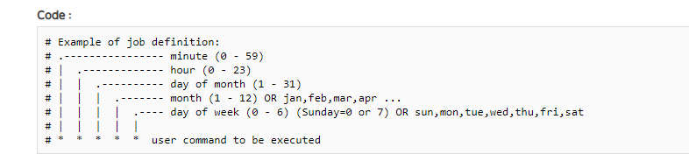
  - Access rights Oracle User
The access can be modified with “visudo” command with root user
We want to be able to mount and umount nfs share with oracle user
Added lines
## Same thing without a password
# %wheel ALL=(ALL) NOPASSWD: ALL
oracle ALL=(ALL) NOPASSWD: ALL

