How to renew SSL certificate for SRVUAGPOM01.erbc-group.it

- Go to vSphere and launch webconsole of “Proxy” virtual machine.
- Inside the vm via terminal digit:
sudo su
sudo cp /home/erbc/docker-NGINX/letsencrypt/live/npm-23/*.pem /home/erbc/Desktop
sudo chown erbc /home/erbc/Desktop/*.pem
- Now from your pc open Filezilla, connect to the proxy server via SFTP and copy all the .pem file on the Desktop to your pc.
- Upload cert.pem and privkey.pem to https://172.16.0.1:9443/admin/index.html#!/Login (vmware UAG)
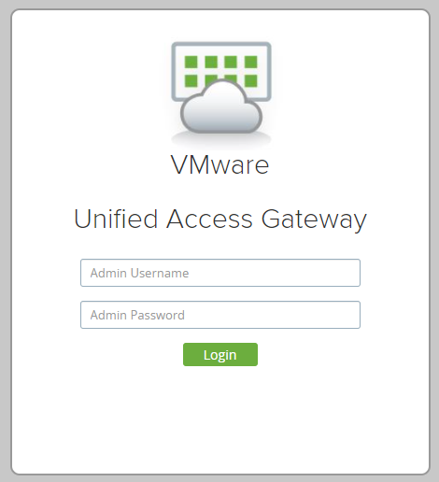

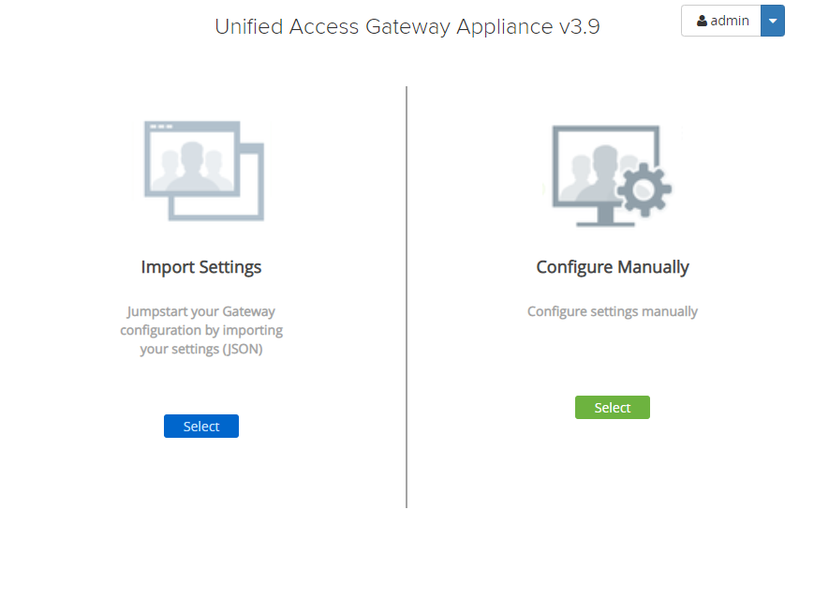
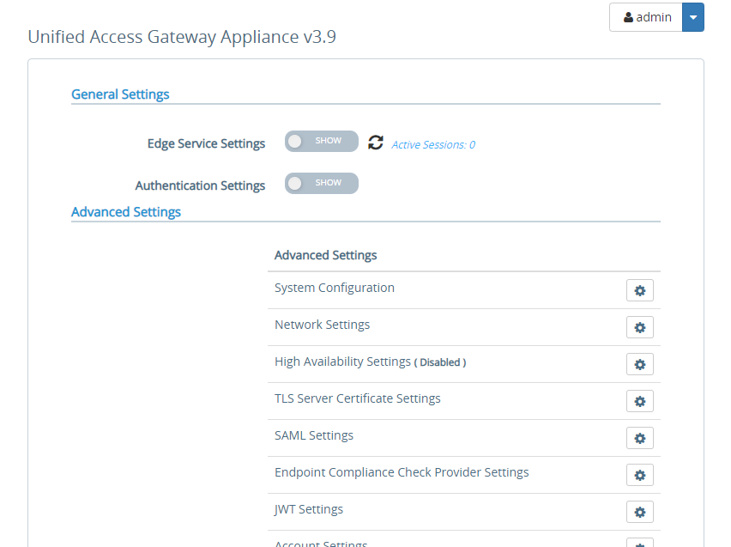
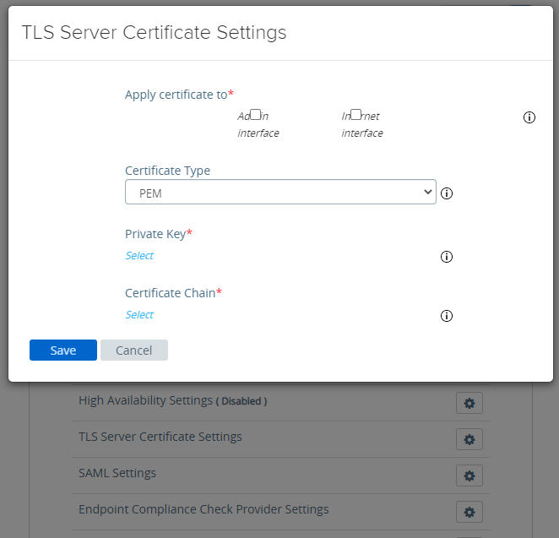

- Upload cert.pem and privkey.pem to https://10.2.22.38/ (Kemp LoadBalancer)
