LabWare
T0013 Bioanalysis V3


Installation Instructions Overview

www.labware.com

Information in this document is subject to change without notice and does not represent a commitment on the part of LabWare. If there are any questions concerning this documentation, please send them to us in writing. LabWare does not warrant that this document is error-free. The software described in this document is furnished under a sub-license agreement or nondisclosure agreement. It is against the law to copy software on any medium except as specifically allowed by the license or nondisclosure agreement. No part of this manual may be reproduced in any form or by any means, including photocopying, for any purpose without the express permission of LabWare.

Copyright © LabWare, all rights reserved.

Change Control
Document Version | Change Control | Changed By / Date
0.1 | Posted with the initial release of version 3.0 | Henryka Reszka/ 08-Jul-2022
0.2 | Expanded Postgres configuration | Jakob Kuehn / 13-Jul-2022
0.3 | Combined Overview, Database and Application Server into one document | Bianca Komoll/15 Sep 2022
0.4 | Added corrections from Feedback to Build004 installation. Updated naming convention of the document | Bianca Komoll/15 Jan 2023
1.0 | Issued for released with unit testing | Neil Parker/ 18th Jan/2023

Contents
1 Introduction 5
1.1 References 5
2 Installation Overview 6
2.1 Installation Models 6
2.2 Background Servers and Schedulers 7
2.3 Shared Resources 7
2.4 Environments 7
2.5 Installer contents 8
2.6 Installation Tasks 8
3 Application installation 9
3.1 Windows Active Directory Groups 9
3.2 Remote/Virtual Servers, Application Servers and Local Clients 9
3.3 LabWare installation 10
3.4 Supporting software installation and operating system configuration 11
3.4.1 Configure Microsoft DEP 11
3.4.2 Labware 8 base installation 12
3.4.3 SSG Support 13
3.4.4 Txt Control 13
3.4.5 Install LAPI32 DLLs 13
3.4.6 R software 14
3.4.7 Background Services – NSSM 14
4 Server and Client Setup 15
4.1 Application Shortcut 15
4.2 Server Connection to the Database 15
5 Database Installation 16
5.1 Target Database Types 16
5.1.1 Oracle Database Setup Parameters 16
5.1.2 Microsoft SQL Server Database Setup Parameters 17
5.1.3 PostgreSQL Setup 18
5.2 ODBC configuration 18
5.2.1 ODBC setup for PostgreSQL 19
5.3 Creation of initial database using DBMT 23
5.3.1 Create SQL Scripts 23
5.3.2 Editing the SQL Scripts 24
5.3.3 Executing the SQL Scripts 25
5.3.4 Post Database Creation SQL Scripts (Oracle database only) 25
5.3.5 Copy Data Using DBMT 26
5.3.6 Database Cleanup in Target Database - OPTIONAL 27
5.3.7 Connect LIMS to Target Database 28
5.3.8 Views 28
5.4 Creation of database for subsequent environments 30
6 Internal LIMS Localisation Changes 30
6.1 External Link Directories 30
6.2 LIMS Constants 31
6.3 Update Crystal Reports 31
6.4 LDAP (if required) 32
6.5 Report Normal.dotm file setup 32
7 Remote/Virtual Desktop Setup 34
7.1 Citrix Setup 34
7.1.1 COM Port Mapping 38
7.2 Terminal Server Installation 38
7.3 Virtual Desktop 42
8 Cluster Manager and Background Service 43
8.1 Cluster Manager - Configure the database connection 43
8.2 Background Service - Configure the database connection 43
8.3 Creating CM Service Records in the Database 44
8.4 Setting up the Scheduler 47
8.5 Creating the Windows Service Manager Service 47
8.5.1 Creating the service with NSSM 47
8.6 Restart All Services 47
9 Appendix A - Environment Descriptions (Configuration Parameters) 49
9.1 Database Layer 49
9.2 Virtual/Remote Servers and Application Server 50
9.3 Cluster Manager 51
9.4 Cluster Manager Services 52
10 Appendix B – Database Installation Log 53
11 Appendix C – Application Installation Log 53

Introduction
This document provides an overview of the Bioanalytical Solution installation process. It is also a reference document containing the configuration parameter values that are specific to each logical environment of the LabWare Bioanalytical Solution application.
Details of the installation tasks for all the layers of the application are described in the individual installation instructions.

References
Installation will be performed based on the following documents:
- [T0013 Bioanalysis V3 Installation Instructions]
- [T0013 Bioanalysis V3 Installation Qualification - Database]
- [T0013 Bioanalysis V3 Installation Qualification - Application Server]
Detail information on pre-requisites can be found in the following white papers:
- [Hardware Requirements for LabWare ELP v8_01]
- [LabWare ELP – Using Citrix v3]
- [LabWare ELP – Oracle Server Guidelines v1.09]
- [LabWare ELP – SQL Server Guidelines v2.05]

Installation Overview
Each layer in the environment requires Installation followed by Installation Qualification (IQ) as an integral part of the process. There is a two-phase process for each layer:
- Logging of successful/unsuccessful steps during the installation process. Separate tables are provided in the installation instructions to log the results of the installation steps and provide evidence.
- Execution and completion of an Installation Qualification (IQ) logging successful/unsuccessful steps.

Installation Models
The following diagram describes the Bioanalytical Solution application at a high level:

The most common installation models are:
Virtual/Remote Server e.g., Citrix, VDI, Terminal Server. LabWare software is installed on the Virtual/Remote server(s) and the Virtual/Remote software is used to provide LabWare access and load balancing.
Served file share. LabWare software is installed on a file share and users run the application from that file share. The users need an ODBC connection to the LabWare database from their client and helper software (e.g. Crystal Reports) must be installed on each client. This method is heavy on network traffic when starting the application and when accessing large datasets.
Local. LabWare software is installed on each client. The users need a ODBC connection to the LabWare database from their client and helper software (e.g. Crystal Reports) must be installed on each client. This method is heavy on network traffic when accessing large datasets. This method is high maintenance for IT support.

Background Servers and Schedulers
LabWare provides the ability to run some functionality in the background on a background server or schedulers. In this case the background server/schedulers need to be installed on an Application Server.
Common uses of schedulers:
- Scheduled LIMS Basic.
- External interfaces via scheduled LIMS Basic.

Shared Resources
For reduced maintenance, it is possible to install the LabWare software on a file server/file share. This is recommended in all cases for:
- Crystal report definitions (…/Reports).
- External link directories.
NOTE: These shared file shares are single point of failure and should be considered when designing for high availability solutions.
The full server directory could also be installed on a file share and accessed from each Virtual/Remote Server or Local Client. Note that this requires good access time to the file share or application start-up will be slow.

Environments
The environments that will be created are as follows:
Optional environments are shown with a *:
Environment | Description | <env>
Development | Development of new configuration and functionality. Created using these instructions informally, no IQ is required. | DEV
Validation | Used for functional/OQ testing. Created using these instructions after completion of Development. Qualified by IQ. | VAL
Production | Used for PQ and Production. Created using these instructions after completion of UAT. Qualified by IQ. | PROD
Ideally the infrastructure for Development, Validation, and Production are completely separate

Installer contents
The installation sources are provided in a zip-file which contains:
- BG_Client
  - Specific client directory for Background Server
  - Contains specified bind log for background to bind special modules only required in BG.
- CM_Client
  - Specific client directory for Cluster Manager Server
  - Contains specified bind log for background to bind special modules only required in Cluster Manger
- Data (External Link Folder for Dynamic and Static Data)
  - Empty folders required as default path during installation.
- Database
  - Initial Access database for DBMT
  - alternatively, PostgreSQL databases for direct PostgreSQL import
- Installers (Supporting Software)
  - LW8 DotNet support
  - Crystal Reports runtime
  - PDF Components
  - LAPI
  - SSG Support
  - Txt control support
  - R (https://www.r-project.org)
  - NSSM (installation tool create windows services for cluster manager lims)
- Reports
  - External Link Reports Folder for crystal reports
  - Separated from server directory for better security control during installation.
- Server (Application Server directory)
  - Contains all necessary modules and files for the system.

Installation Tasks
The installation process described in the set of LabWare installation documents is for one logical environment (e.g. Test) which may consist of one or more servers at each layer. Additionally, two or more logical environments may share a server platform. The order of installation is:
- Verify pre-requisites are in place, complete and sign the confirmation log.
- Install the first application server, completing all steps. Collect evidence for each step. Complete and sign the install log in case a documented IQ is needed.
- Connect your lims with the access database available in the installation tip and login the first time
- Follow the steps for the database installation to migrate all configuration from the access database to your target database
- Create tables, indexes, views and initial database content. Collect evidence for each step. Complete and sign the install log. The installation requires access to a SQL editor.
- Connect your LIMS with your new target database via ODBC.

Application installation
This section describes the installation of the LabWare Server application on Remote/Virtual Desktop and Application servers or local clients. Internal changes to the LabWare configuration are also described and should be performed as part of the installation of the first server.
The installation instructions include Appendix C which should be completed after each step by the Installer. The steps requiring confirmation and evidence are pre-documented in the table. On completion of the installation, it is required that you also execute the tests in the Installation Qualification Application Server document (see Ref [2]) to verify that the completed configuration is as expected.

Windows Active Directory Groups
- Active directory groups have been created.
  - LW_<env>_ADMIN – for Admin access.
  - LW_<env>_USER – for end-user access.

Remote/Virtual Servers, Application Servers and Local Clients
- The correct Windows version is installed (OS version that supports Microsoft .NET Framework 4.5 or later)
- Microsoft .NET Framework 4.5 or later is installed.
- Remote/Virtual software is installed.
- Database client software is installed.
- ODBC drivers are available.
- Windows domain user account is available.
- Microsoft Visual C++ 2012 Redistributable
- Microsoft Visual C++ 2013 Redistributable
- Microsoft Visual C++ 2017 Redistributable
- Adobe reader 32 bit (no automatic updates, prevent update to 64bit)
- Microsoft Office 365 (Excel and Word required to run method validation report and study evaluation report)
- LDAP user account or proxy is available if using LDAP.
- Regional settings set to English for all users. The system requires decimal symbol dot (.) and list separator symbol comma (,) to work correctly.
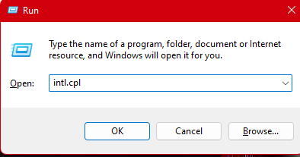

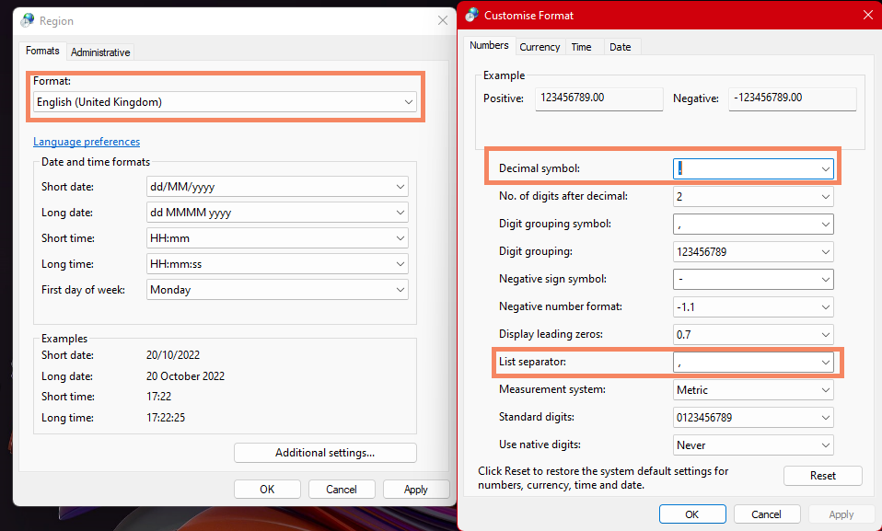

LabWare installation
The software can be unzipped on a network storage device or to a directory on a server.
Note that on the second and subsequent application servers, the directory server should be copied from the first server.
Create the application directories and software.
- Unzip the LabWare Bioanalytical Template software in the application install directory <<install path>>.

On the second and subsequent servers the software does not need to be installed if the software is to be used from the public share. If access to the public share will be too slow at application start-up, then the software can be copied to each subsequent server. Only the Server and Client directories need to be copied.
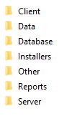
- Create a public share <<share name>> to the install path in order that the service account running on the other application servers can access the installed files on this server.

- Grant access to the public share to the administrative groups:
  - LW_<env>_ADMIN; full access
  - LW_<env>_USER; read only.

- Grant access to the LIMS directories:
Directory | Access rights
Server/… | Users: Read Only  Admin: Full Control
Client | Users: Read/Write/Create/Delete  Admin: Read/Write/Create/Delete
Reports | Users: Read/Write  Admin: Full Control
Data/Static | Users: Read/Write/Create/Delete  Admin: Read/Write/Create/Delete
Data/Dynamic | Users: Read/Write/Create/Delete  Admin: Read/Write/Create/Delete
Data/Secure Reports | Users: Read/Write/Create/Delete  Admin: Read/Write/Create/Delete

- Update License Files. The Bioanalytical Solution server directory comes with no valid customer license files. The customer license file needs to be downloaded from the LabWare support website and copied to server directory.

Supporting software installation and operating system configuration
Note: Additional Software Installers are provided in the “Installers” package

Configure Microsoft DEP
To be performed on all servers/clients. Note that this step is not always required if DEP was not activated on the server.
DEP needs to be disabled for LabWare.
- Turn off DEP for the executables (Labware.exe).
- Computer> System Properties >Advanced System Properties>Performance>Settings. Executable is in folder:
<<Install Path>>\Server

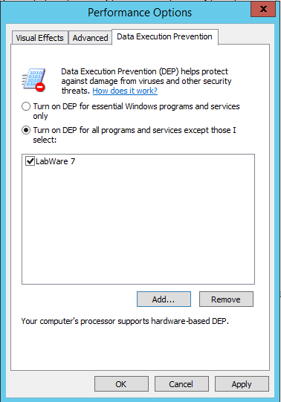

Labware 8 base installation

Use the LabWare 8 base installer “LabWare 8.0.0.6 Setup.exe” which will guide you throught the installation process and will install the base Folder structure and the components dotNet Support, LabWare PDF Component and Crystal Runtime Files automatically.

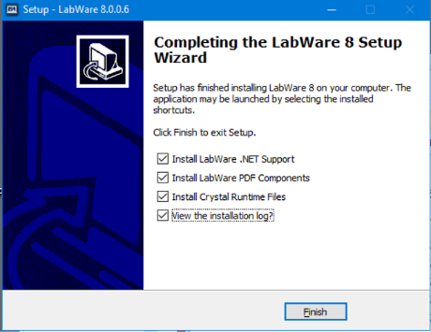

SSG Support
SSG support needs to be installed if ELN is to be used.
NOTE: Any previous version should be uninstalled before starting.

Txt Control
To be performed on all servers/local clients.
NOTE: Any previous version should be uninstalled before starting.
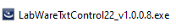

Install LAPI32 DLLs
To be performed on all servers/local clients.
NOTE: Before running this step, refer to KT01377 which has the latest instructions for how to install the DLLs.
There should not be any other copies of these dll’s in the system. This needs to be done on each client system that is running LabWare and / or Crystal Reports developer.

A summary of the install instructions is given here:
- Place the Lapi32.dll in the "C:\Windows\SysWOW64" directory
- Remove any U2Lapi32.dll file found in the "C:\Windows\SysWOW64" directory
- Copy the new U2Lapi32.dll into Crystal Report's .Net Common 32-bit directory
- Also, copy the new U2Lapi32.dll into the directory where the "CRW32.EXE" file lives
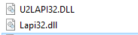

R software
To be performed on all servers/local clients. Installation is expected to be performed with the default settings.
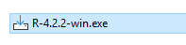
Start RGUI.exe and install package “minipack.lm”, this step is only required if you will perform update from previous version of R to the one defined in this document.
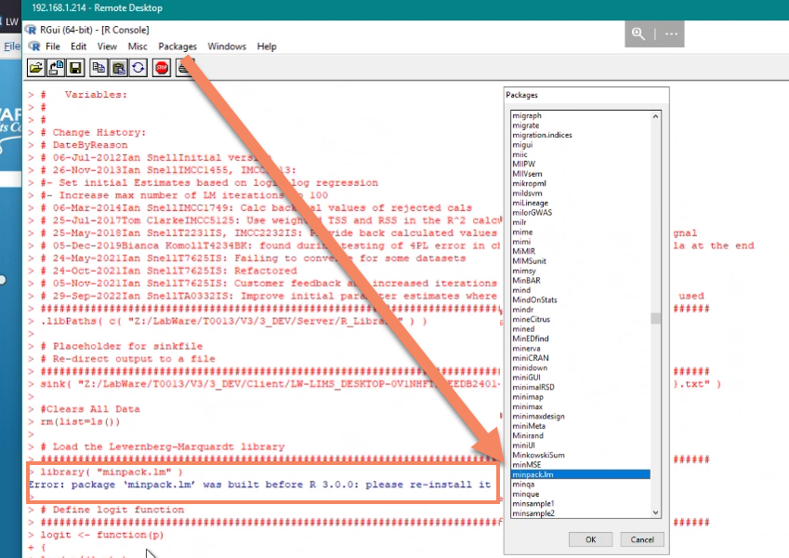

Background Services – NSSM
To be used on background servers. Please referee to KT01312 for more updated information on the install and setup.

Server and Client Setup
This section configures the software to connect to the database and sets the client name. It is assumed that the ODBC configuration has been performed as described in Section 3.4.

Application Shortcut
- Create an application shortcut so that LabWare can be started.
Location: <<install path>>\Server\LabWare.exe
Start In: <<install path>>\Client

Server Connection to the Database
The server connection configuration is required to connect the LabWare application to the correct database.
- Create a ODBC connection to the access database available in the installation zip folder “Database”. See details for ODBC creation in chapter 5.2.
- Start using the shortcut created and use the menu “Configure, System, Server” to set the database connection parameters.
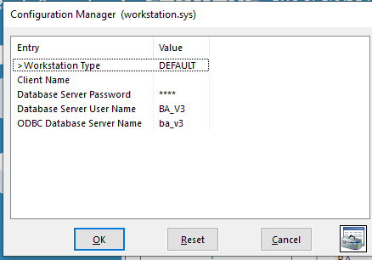

- Choose the ODBC DSN created before, user name and password are not required in the access database and can be confirmed as empty
- Login to lims with standard login user
- Note: database error messages appear about missing views can be accepted as this point of installation. The views will be created in a later step.
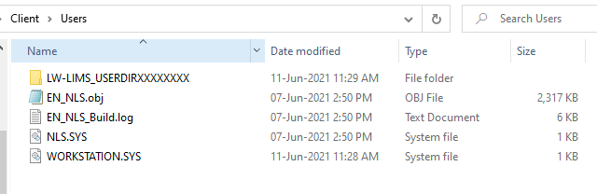
You should also copy this to any scheduler folders, so they use the correct workstation sys file. This would be done if you are setting up multiple schedulers. For demo or development setups this step may not be needed.

Database Installation
Note that the database pre-requisites should be shared and discussed with a DBA if available. The Bioanalytical Solution is designed to work with Oracle, SQL Server and PostgreSQL. Any current/supported version of the database platform is supported. Typically, most customers will opt for a stable version and the most current version/beta version of databases are not recommended. Note that ODBC drivers should be matched to the database and are important to have correct versions.
Refer to the corresponding white paper for Oracle (7) and SQL Server (8) for more detailed information.
This document assumes that:
- Requested new target database or schema is available.
- Requested target database users are available. Note: passwords to be maximum length 20 and non-expiring. Generally, one user is appropriate to avoid any issues with Schemas in oracle as sequences are created. This should be reviewed with a DBA.
  - It is recommended the user have the environment name within it such as LW_DEV_USER. This user must have the privileges to create/modify tables/views/indexes/sequences.
  - In some cases you may want a read only or limited user for interfaces that access the system externally.

Target Database Types

Oracle Database Setup Parameters
Refer to LabWare ELP – Oracle Server Guidelines v1.09 for more detailed information. We recommend automatic auto-extending of tablespaces and auto-memory management where possible. Items in Bold are required for LabWare to work correctly the other parameters shown are typical.
Parameter | Value
pga_agregate_target | e.g., 100M
sga_max_size | e.g., 800M
sga_target | e.g., 800M
Memory target | e.g., 1G
Memory target max | e.g., 1G
Block size | 16K
Db_file_multiblock_read_count | 256
Max concurrent processes | Use a value of n sessions + base Oracle requirements  n sessions = (concurrent Users) * (num sessions/user)  num sessions/user = 4 (use 4 or larger is recommended)  base Oracle requirements = 15 (consult your dba for more details)  So for a 25 user concurrent system this value would be 115 OR LARGER
NLS_CHARACTERSET | AL32UTF8
NLS_LENGTH_SEMANTICS | CHAR – note that the length semantics in the database should be BYTE as recommended by Oracle, but the session should use CHAR.
NLS_NCHAR_CHARACTERSET | AL16UTF16
NLS_LANGUAGE | e.g., AMERICAN
NLS_TERRITORY | e.g., AMERICA
NLS_SORT | e.g., BINARY
NLS_COMP | e.g., BINARY
Other Initialisation parameters | None specified
Table Spaces | LW_<env>_DATA 30,000 blocks  LW_<env>_INDEX 30,000 blocks  LW_<env>_AUDIT 30,000 blocks

- Oracle Special Considerations
  - Schemas are users so care must be taken if multiple users are desired that can create db sequences (Bioanalytical Solution uses LIMS increments as default not sequences)
  - Modifications to TNSNAMES.ORA to be performed on all servers or on the shared TNSNAMES location. EasyConnect strings can also be used, in which case TNS is not required.
  - See KT0804 for notes about Oracle Real Application Clusters (RAC) as this can result in some degree on non-continuous sequences/records/keys. It is not a functional issue but a cosmetic issue.
- Requested tablespaces/storage is available. Note that using different tablespaces for data, audit tables and indexes can improve performance if the tablespaces are stored in separate locations to allow parallel access.

Microsoft SQL Server Database Setup Parameters
Refer to LabWare ELP – SQL Server Guidelines v2.05 for more detailed information. Additional References are:
- LabWare KnowledgeTrack KT01018
- LabWare KnowledgeTrack KT01019
- https://msdn.microsoft.com/de-de/library/ms143508(v=sql.105).aspx
We recommend automatic auto-extending of tablespaces and auto-memory management where possible. Items in Bold are required for LabWare to work correctly the other parameters shown are typical.
Database setup:
Authentication Mode | SQL Server authentication
Recovery Model | Full (Productive LIMS), Full or Simple (other instances)
Compatibility Level | SQL Server 2014

ODBC Drivers and Settings
ANSI quoted identifiers | on
ANSI Nulls, paddings and warnings | on

PostgreSQL Setup
Refer to Knowledge Track KT01415 for more detailed information. The default settings for new databases are acceptable. There are two main areas of caution when setting up a new PostgreSQL system that are discussed in the KT:
- ODBC - A potential source of problem is the few items in the ODBC that must be changed from default and are detailed in the KT. These are the Max LongVarChar should be 1000000, checking “Show System Tables”, checking “bytea as LO” (should be checked by default) and the “Level of Rollback Errors” set to “Statement”.
- User Search Path – the default database schema is setup as lwlims so the database user must have the lwlims schema in the Search Path. More details in the KT.
A PostgreSQL backup file is included in the install package so you can restore this directly into your new database with minimal changes. In this case the DBMT steps are not required and you can skip steps in chapter 5.3 .

ODBC configuration
To be performed on all servers/local clients. Note that the ODBC DSN should be identical for all servers/local clients.
The ODBC DSN for the target database must be set up for use by the application.
Use the ODBC applet odbcad32.exe to create a new system ODBC DSN connection using the relevant settings for the environment.
Use the version of the applet odbcad32.exe in C:\Windows\SysWOW64 to create a system DSN.
Choose the 32-bit Oracle driver or an appropriate SQL Server driver.
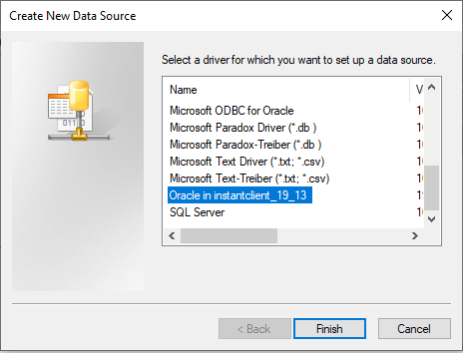

ODBC setup for PostgreSQL
The ODBC Driver for PostgreSQL should be installed (if it is not already present). You can get the current ODBC driver for your DB Version from this web page:
https://www.postgresql.org/ftp/odbc/versions/msi/
For example, if using a PostgreSQL 10 database, you would get “psqlodbc_10_03_0000-x86.zip” or the equivalent newer version. Just match the ODBC main version to your database version and ensure you get the x86 (and not the 64bit) version as we are using a 32bit app.
From the 32bit ODBC, choose “System DSN”, then “Add” and make sure to get the Unicode version of the PostgreSQL ODBC Driver.
You will need to ensure the ODBC is setup correctly, here is an example ODBC setup:
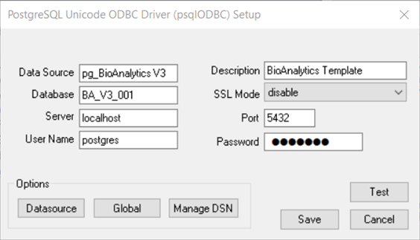
Note that port 5432 is the default port for new PostgreSQL installs. If you have more than one PostgreSQL install on your server, you could end up with a different port. Check the database properties to ensure the port is correct.
Also, if you add the username and password to the ODBC and save it LIMS will not need to have the server sys details filled in for user/password. This is fine for demo/development systems, but not recommended for production systems.

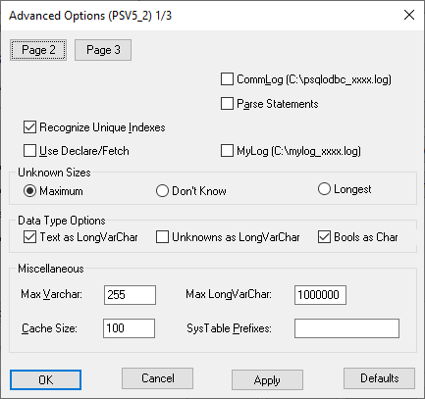
The “Max LongVarChar” should be increased from the default as shown above.
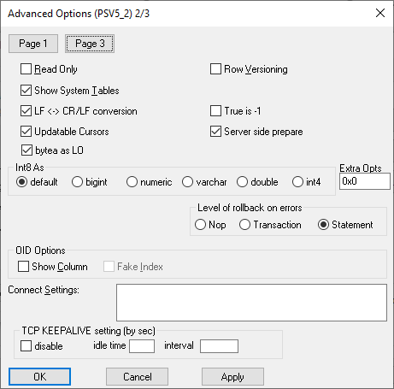
Check boxes for “Show System Tables” and rollback as “Statement” and confirm “Bystea as LO” is checked.
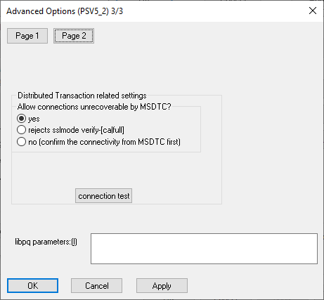
No changes on this screen from default.
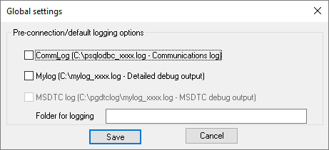
No changes on this screen from default.
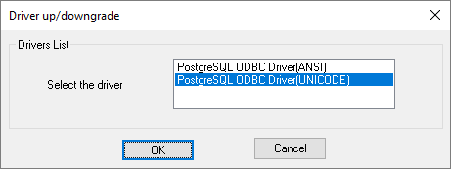
No changes on this screen from default.

Creation of initial database using DBMT
Note: Only step 5.3.8(view creation) is required if using the supplied PostgreSQL backup. Please skip all other steps.
The initial Development database will be created by copying the Bioanalysis Template Access database using the LabWare DBMT utility. Note that a LabWare application server must be installed first which will be run against a local Access database (provided in the Database package).
There are several methods to create the tables and indexes:
- Using the LabWare DBMT utility and SQL scripts.
  - Create SQL scripts using the LabWare DBMT utility.
  - Execute the SQL scripts.
  - Copy data using the LabWare DBMT utility.
- Using native database tools e.g., Oracle SQL Developer
An example installation log is shown in Appendix B

Create SQL Scripts
Login to the source LabWare system (e.g., Dev when creating the Test database) using a system account.
Select Utilities, DBMT.
Select a target database (any) and type. Add the target owner (Oracle schema).
Select all tables and click the Create Scripts radio button, then click start. Note that any views must be left unselected.
DBMT will create two scripts in the server directory.
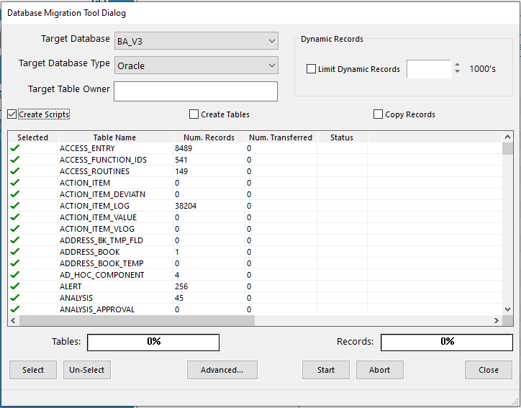

The DBMT tool will show all entries listed in the TABLE_MASTER which can be on database level a table but also a view. Views SHOULD NOT BE CREATED via the DBMT tool but will be created later with the build in functionality in menu Debug > Rebuild Views which will cover different syntax for different database types.
The list of Views in the database which should be UN-SELECTED in DBMT :

View Names
C_SAMPLE_FLAGS_VW
C_VW_BATCH_SOURCE
C_VW_STUDY_VAR
EXPERIMENT_DATA
SAMPLE_VIEW
T_STORAGE_LOC_VW
T_VW_REORDER_LH
T_VW_STK_ITM_ENTRY
VW_ALL_SAMPLE_FLAGS
VW_BA_STUDY_ISR_RESULTS
VW_CR_EVAL_SEQ_SAMPLE
VW_EXPERIMENT
VW_METHOD_SEARCH
VW_PENDING_DECISION_SAMPLE
VW_PREP_FOR_SEQ
VW_RECEIVED_SAMPLE
VW_SAMPLES_IN_QURNT
VW_SAMPLES_NOT_QURNT
VW_SEQ_ANALYTE_VIOLATIONS
VW_SEQ_CREATION
VW_SOL_SOURCE_SEARCH
VW_STOCKSOL
VW_STOCKSOL_SEARCH
VW_STOCKSOL_TO_SEQ
VW_STUDY_FLAGS
VW_T_EXPORT_DATA
VW_TOXKIN_DATA
VW_TSOS_CAL

Editing the SQL Scripts -OPTIONAL
The files created by the DBMT are saved in your CLIENT Dir. Edit the two SQL scripts and add any additional details required. Rename the scripts as:
LW_<env>_SCRIPTS.SQL
LW_<env>_INDEX.SQL.

Example editing for Oracle
In Oracle the Initial and Next extents can be set on the large dynamic tables to reduce fragmentation. Tables to be considered include SAMPLE, TEST, RESULTS, PROJECT, EXPERIMENTS, WORKBOOK_DATA, STORAGE_LOCATION, and all table audit log tables.
In Oracle when using LW_<env>_DATA, LW_<env>_AUDIT and LW_<env>_INDEX tablespaces, all audit log tables should be in the LW_<env>_AUDIT tablespace and all indexes and constraints in LW_<env>_INDEX, all other tables can be in LW_<env>_DATA.
Note that as stated in the pre-requisites, the database account used needs to have the LIMS default tablespace assigned, or the tablespace for Oracle needs to be added in the storage clause.

Executing the SQL Scripts
Login to a SQL editor using the correct admin database account and the target database/schema.
Execute the following scripts, ensure that the script output is captured and checked for errors:
- LW_TABLES.SQL
- LW_INDEX.SQL
Store the SQL scripts for later reference.

Post Database Creation SQL Scripts
The database fields PROJECT.T_BATCH_ANALYTES and PROJECT. T_STUDY_TITLE are text fields which should hold information with ~1000 characters. Text fields will be reduced to size 254 by the access database within the initial installation package. Therefore, these fields must be manually updated by SQL script to correct size. Below you find the example for Oracle database syntax. Please adjust if you use another database type.

Oracle Example:
/* Alter T_BATCH_ANALYTES field size */
ALTER TABLE PROJECT ADD T_BATCH_ANALYTES_2 VARCHAR2 (1000);
UPDATE project SET T_BATCH_ANALYTES_2 = dbms_lob.substr(T_BATCH_ANALYTES, 1000, 1);
ALTER TABLE project DROP COLUMN T_BATCH_ANALYTES;
ALTER TABLE project rename COLUMN T_BATCH_ANALYTES_2 TO T_BATCH_ANALYTES;

/* Alter T_STUDY_TITLE field size */
ALTER TABLE PROJECT ADD T_STUDY_TITLE_2 VARCHAR2 (2000);
UPDATE project SET T_STUDY_TITLE_2 = dbms_lob.substr(T_STUDY_TITLE, 2000, 1);
ALTER TABLE project DROP COLUMN T_STUDY_TITLE;
ALTER TABLE project rename COLUMN T_STUDY_TITLE_2 TO T_STUDY_TITLE;

You must ensure that the FACTOR field in the UNITS table and result numeric fields (eg. RESULT.NUMERIC_ENTRY and REPORTED_RESULT.NUMERIC_ENTRY have the precision required to correctly convert units.

/*Oracle script only*/
ALTER TABLE UNITS
MODIFY (FACTOR NUMBER(38, 21) );

ALTER TABLE RESULT
MODIFY (NUMERIC_ENTRY NUMBER(38, 21) );

ALTER TABLE REPORTED_RESULT
MODIFY (NUMERIC_ENTRY NUMBER(38, 21) );

This must be done in Oracle database before copy data using DBMT will begin.

Copy Data Using DBMT
Login to the source LabWare system (e.g., Dev when creating the Test database) using a system account.
Note that if the tables are created directly via DBMT (not as recommended above), then as stated in the pre-requisites, the database account used needs to have the LIMS default tablespace assigned.
Select Utilities, DBMT.
Select the target database and type. Add the target owner (Oracle schema).
Select all tables and click the Copy Records radio button, then click start. Note that any views must be left unselected.

Database Clean-up in Target Database - OPTIONAL
After the database has been created via either of the mentioned methods (by script or DBMT utility), its records must be cleaned, and increments reset before use in a system. The system copy was created from an existing test system with existing test data present.
Clean-up scripts for the respective database type can be generated by the subroutine UTIL_DB_CLEAN_BA using table list BA-DB_CLEAN_TO_PRD.
🔺Note that clean up script subroutine UTIL_DB_CLEAN_BA is just a template, for the remaining environments decision needs to be made which data is to be moved to the next environment, e.g., STORAGE_LOCATION, STOCKS, STANDARDS AND REAGENTS. Please adjust the subroutine UTIL_DB_CLEAN_BA and the Table List BA-DB_CLEAN_TO_PRD to your project needs!
Important: Always perform a full backup of the database which should be cleaned prior to the execution of the clean-up scripts.
The Subroutine will generate an SQL script which can be executed in a database editor of your choice.

Connect LIMS to Target Database
- Create an ODBC connection to the target database created in the previous steps. See details for ODBC creation in chapter 5.2.
- Start using the shortcut created and use the menu “Configure, System, Server” to set the database connection parameters.

- Choose the ODBC DSN created before login with your target database user name and password.
- Login to lims with standard login user.
- Set the Workstation Type to DEFAULT (or the appropriate type for the client being setup). Use separate Workstation Types (BG_USER, CM_USER) is configuring the Background Server / Cluster Manager.
- If needed, copy the correct updated file named WORKSTATION.SYS from the Client\Users specific directory to the root of the \Client\Users folder (same place as the nls obj files show up) and to each of the Client directories on the application server (Scheduler, Service1). The workstation sys file should not be placed in the \Server folder, this is not valid in LabWare 8, and it will be ignored, it must be at the client root.

Views
Several Views must be manually created in your target DB as the DBMT will not create views.
NOTE: Access database is used only for database migration and not to be used for demo purposes.
We are using the common utilities T0057v1.0_T9069AH DB View Management tool to maintain and rebuild views. All views for the BA Template are available in the SQL Snippet Table set as Snippet Type = View
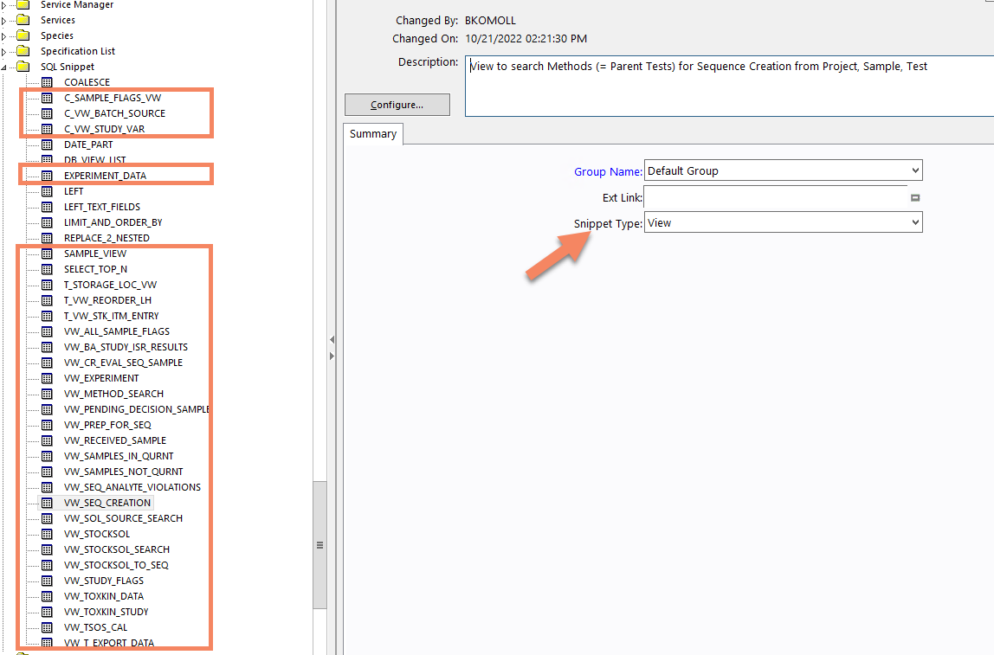

Use the main menu Debug > Rebuild Views which opens a selection of all SQL Snippets for the given Database type. Execute the menu in your TARGET database. Do not execute the menu while the access database is still connected to LIMS.
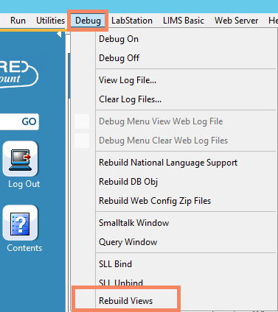
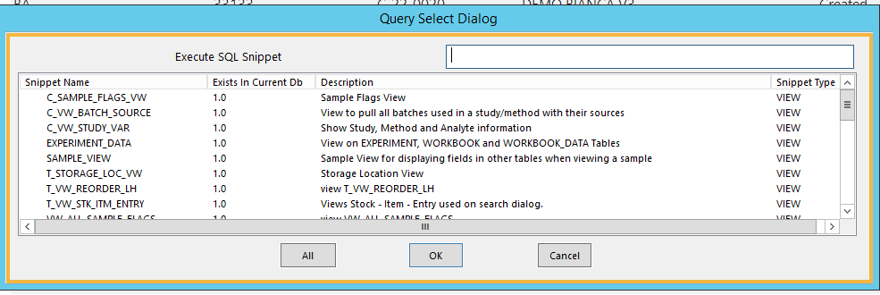

Creation of database for subsequent environments
If already having a source database (e.g., Development database) you can create a backup of this database and use this as a starting point for the new environment. Typically, the following sources will be used:
- The Test database will be created from the Development database. Dynamic data will then be deleted from the database.
- The UAT database will be created from the Test database. Dynamic data will then be deleted from the database.
- The Production database will be created from the UAT database. Dynamic data will then be deleted from the database.
- The Training database can be created from the UAT or Production database.
- The Demo database can be created from the Dev database.

Internal LIMS Localisation Changes

External Link Directories
To be performed on the first server/client only.
External link directories define where the application refers to files stored outside the application e.g., Crystal report definition files.
Configuration only needs to be performed on one server because the configuration is stored in the application database. Note that the UNC path to the first application server public share must be used wherever <<install path>> is referenced.
- Start using shortcut created at the beginning of the installation and login using a system account (user SYSTEM or role R_ADMINISTRATOR).
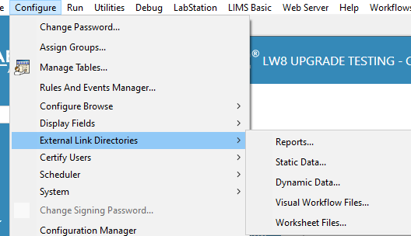
- Set the reports directory to:
<<Install Path>>\Reports
- Set the Visual Workflow Files directory to:
<<Install Path>>\Server\common\visualworkflows

- Set the Static Data directory to:
<<Install path>>\Data\Static
- Set the Dynamic Data directory to:
<<Install path>>\Data\Dynamic

LIMS Constants
In LabWare open Explore Tables and set the values of the LIMS Constants:
DEFAULT_EXPORT_FOLDER <<install path>>\Data
LABEL_PRINT_MODE WEB
SYSTEM_LIVE Should be true for production and false for other environments
TEST_EMAIL_ADDRESS For non-production environments. Emails will be sent to this address
T_R_HOME C:\Program Files\R\R-4.2.2\
T_R_LIB_PATHS <<install path>>/Server/R_Library (Note: / - right slash must be used)

Update Crystal Reports
Open Table Manager on the Subroutine table.
Create a new record and paste the following code:
pathName = GetReportsDir()
status = CrystalSetTableLocations(pathName, pathName, "T")
Execute the code.

LDAP (if required)
Check the LDAP server is configured by logging on to and selecting table LDAP servers in Table Manager.
Check that the Proxy UID and Proxy password are able to access the relevant Active Directory.
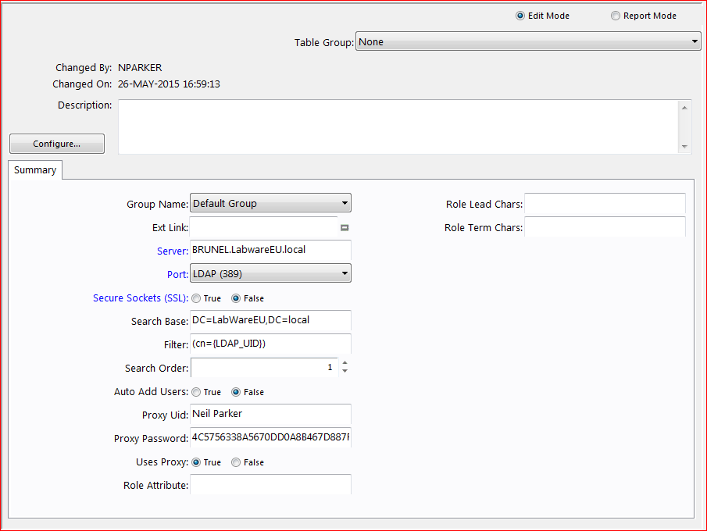

Report Normal.dotm file setup

The final study report will be generated by document generator using MS Word macros. This requires the correct setup of the MS Word normal.dotm file for the system.
Please also refer to the prerequisites in chapter 3.2 which require MS Word/ Office to be installed on the server upfront.
The system expects the standard path from Microsoft to be:
C:\Users\{windowsUser}\AppData\Roaming\Microsoft\Templates\Normal.dotm
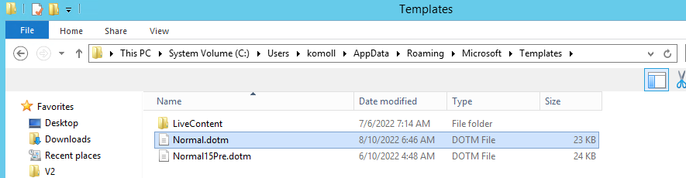
If the path is different, please go to subroutine QT_GEN_SE_REPORT_DG and modify the expected path accordingly in code line 23.
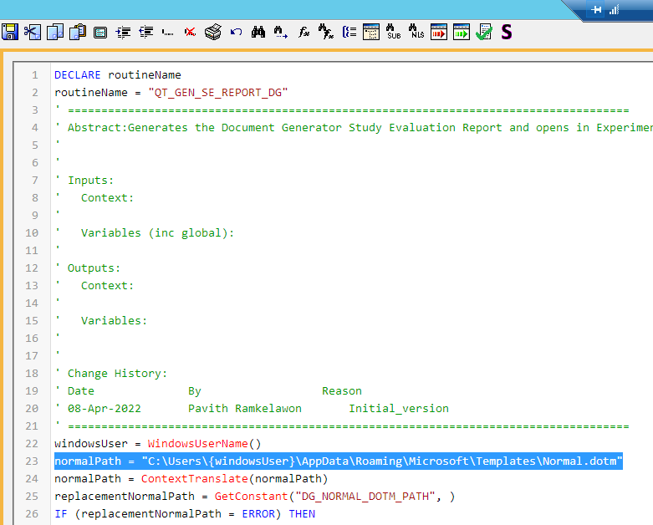
The system will copy the normal.dotm file to a location more accessible for the lims. This location is defined in lims constant DG_NORMAL_DOTM_PATH. Please modify the path in the lims constant according to your installation:
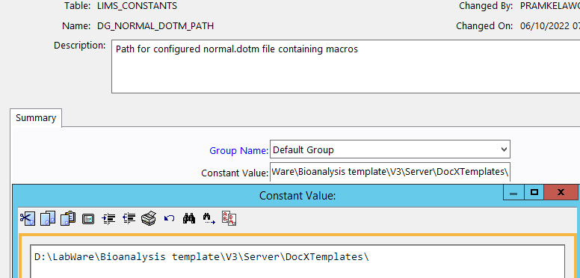

Remote/Virtual Desktop Setup

Citrix Setup
In Citrix Console create the application (Citrix servers only).
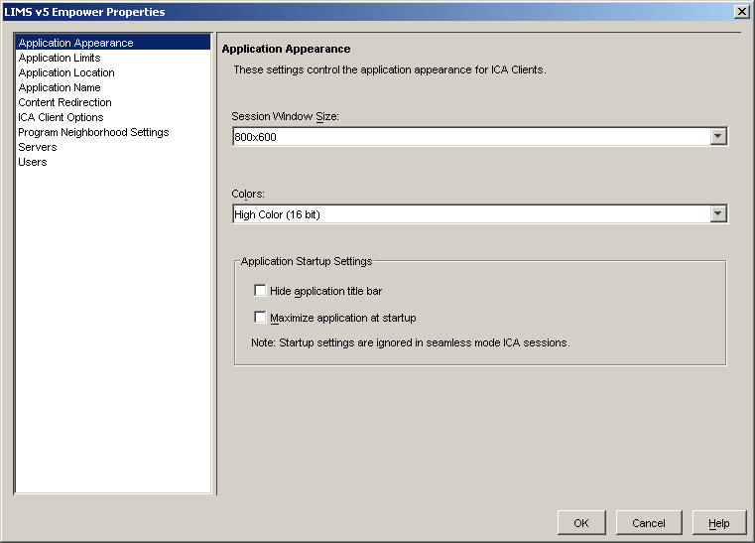

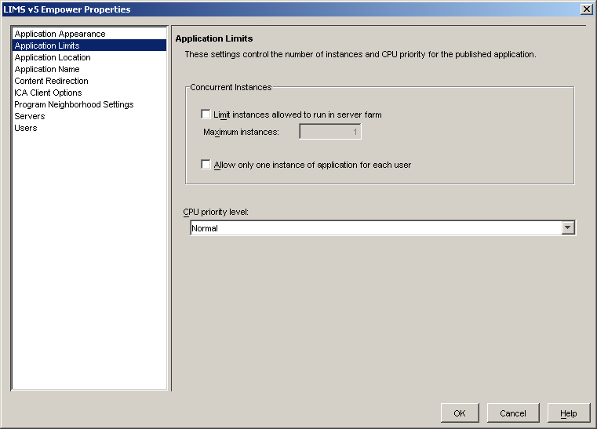
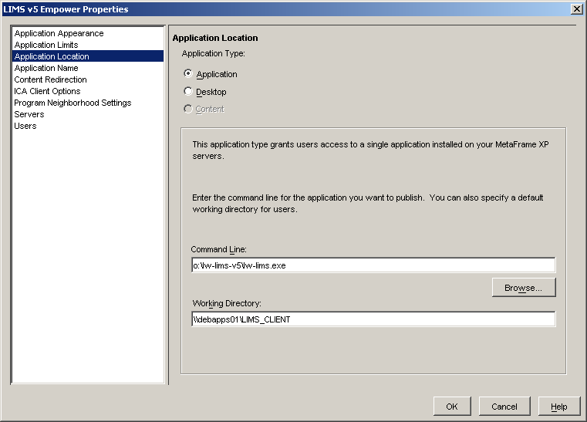
Set the command line and working directory.
Command line: <<install path>>\Server\Labware.exe ;TS=1
Working Directory: <<install path>>\Client
Set the application description.
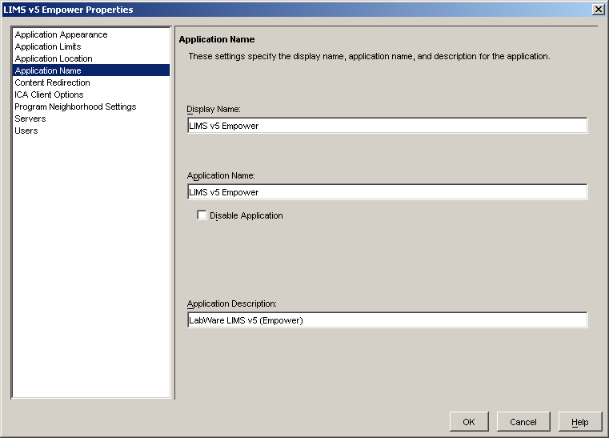

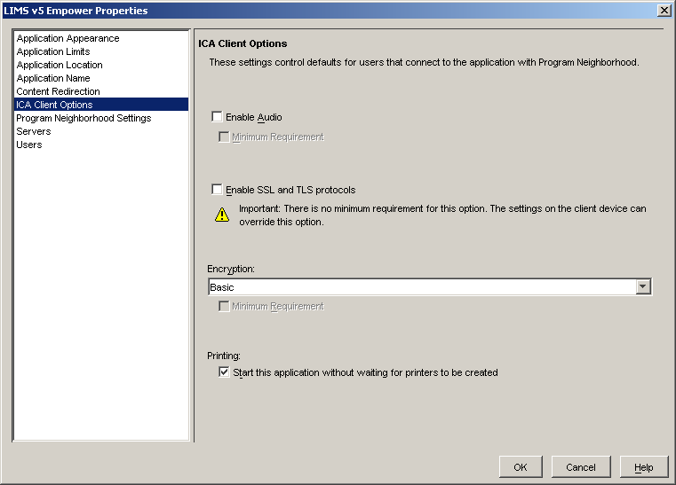

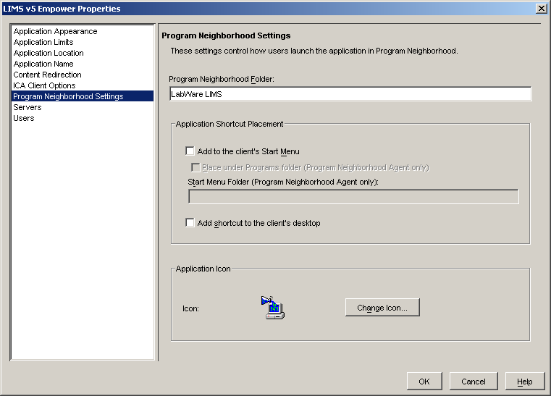

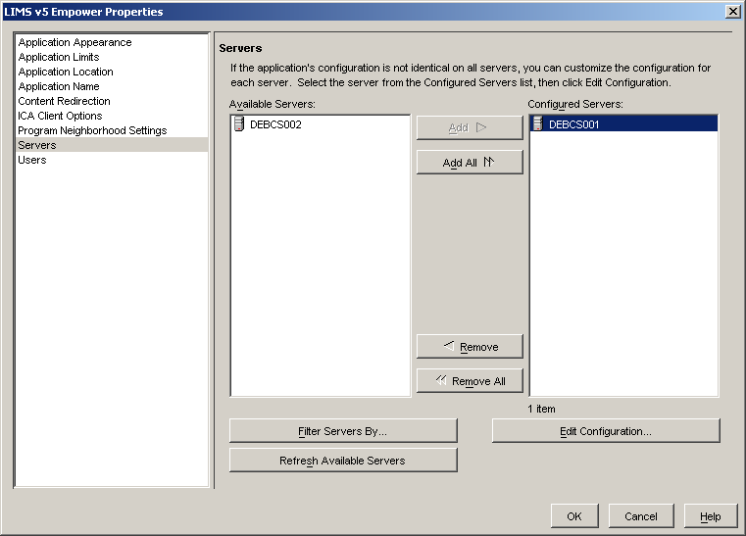

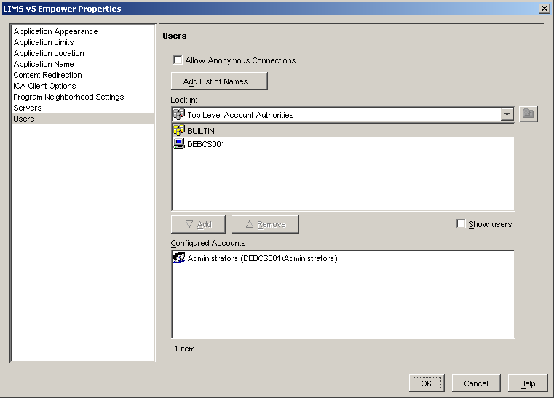

COM Port Mapping
Logon.cmd scripts in Citrix need to be modified to add the COM port mapping (depends on Citrix version, newer versions allow this via administrator settings).
e.g.
CHANGE CLIENT COM1: COM1: /persistent
CHANGE CLIENT COM2: COM2: /persistent
CHANGE CLIENT COM3: COM3: /persistent
CHANGE CLIENT COM4: COM4: /persistent

Terminal Server Installation
Access to the terminal server is via Windows RDP.
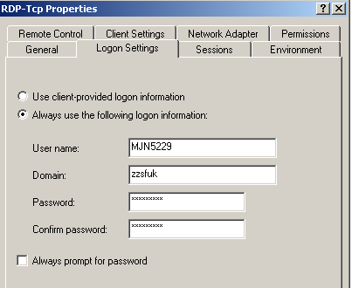
The user ID for login can be fixed or always prompted.
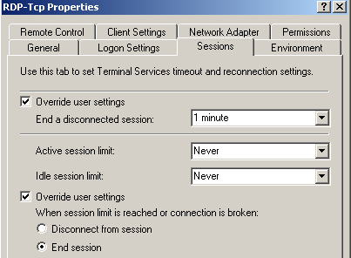
The above settings allow the terminal server to end a disconnected session after 1 minute and stop connections above the server’s license threshold from being made. This auto end of a disconnected session is to overcome limitations of session reconnect from terminal servers by non-originating client pc’s. Under normal operation a user should be logging off the LabWare terminal server session, this end disconnected allows for scenarios such as inadvertent disconnects to be reset.
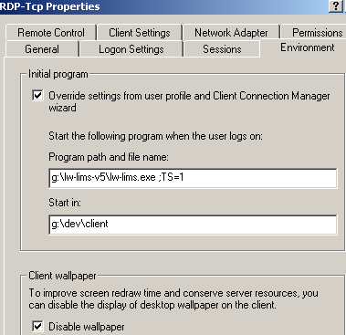
Program path and file name: <<install path>>\Server\Labware.exe ;TS=1
Start in: <<install path>>\Client

The above settings prevent user’s from accessing an open desktop on the terminal server and ensure that the only application presented to them is the LabWare executable with its required parameters. The override switch is set to on which forces this setting to any RDP client connections
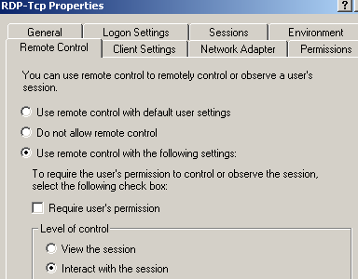
The above setting allows for a server administrator to open a copy of the user’s session on the server console for fault rectification. This is a limited access function.

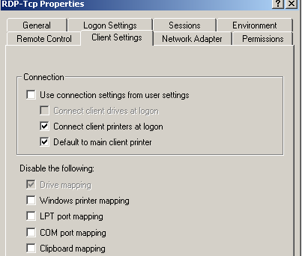
The above options allow for the terminal server to control the client connectable / mappable functions being permitted for use. For LabWare the client printers and default printer mapping are made. The greyed disable drive mapping is set by domain policy and is further overridden from within active directory

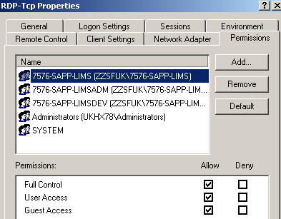
Connectivity to the terminal sever RDP protocol is limited to user accounts that are members of the selected groups as above.

Virtual Desktop
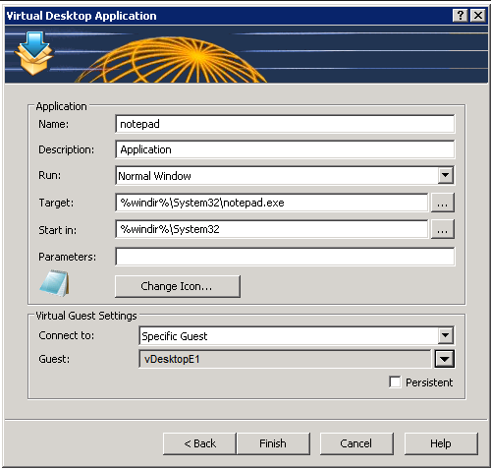
Target: <<install path>>\Server\Labware.exe ;TS=1
Start in: <<install path>>\Client

Cluster Manager and Background Service
To be performed on the first application server only.

Cluster Manager - Configure the database connection
Create an application shortcut using:
- Executable: <<install path>>\Server\CM_Labware.exe ;TS=0
- Working directory: <<install path>>\CM_Client

Start the shortcut.
Use menu Configure, System, Server and set the database connection:
Make sure the workstation type is set to CM_USER.

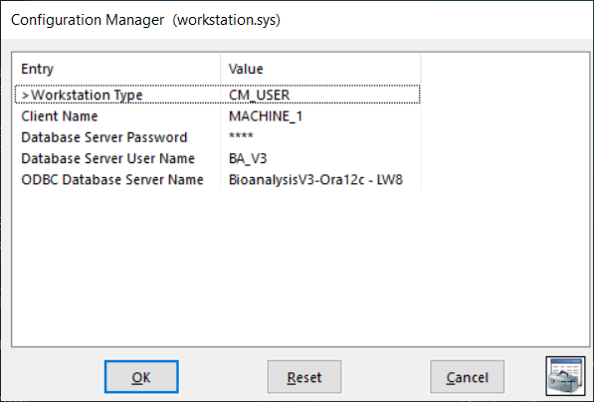

Background Service - Configure the database connection

Create an application shortcut using:
- Executable: <<install path>>\Server\BG_Labware.exe ;TS=0
- Working directory: <<install path>>\BG_Client

Start the shortcut.
Use menu Configure, System, Server and set the database connection:
Make sure the workstation type is set to BG_USER.

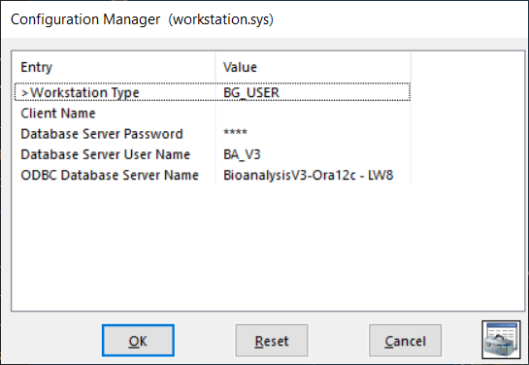

Creating CM Service Records in the Database
Cluster manager provides the LabWare background sessions that the Java layer connects to. Cluster manager runs as a Windows server using the SRVANY Windows toolkit tool.
The Cluster Manager Service configuration is stored in the database and only needs to be set up once per environment repository. This will be done automatically when using the System Setup in Section 6.1. The directories below are shown as examples only and are not the final directories.
- From menu Configure, Table Manager. Open Table CM Service and Open Entry BACKGROUND1

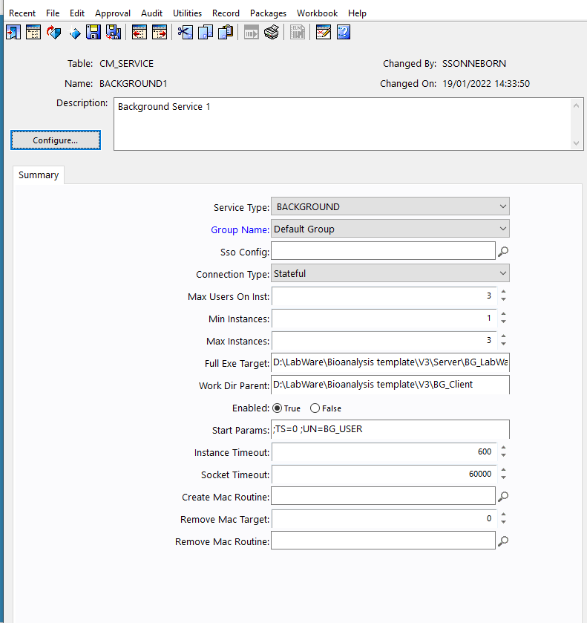

- Make sure the service type is set to BACKGROUND
- Set the Full Exe Target to:
<<Install Directory>>\Server\BG_LabWare.exe
- Set the working directory to:
<<Install Directory>>\Client\BG_Client
- Set the start params: to ; TS = 0; UN = BG_USER
- Save the record; File >> Save.
- From menu Configure, Table Manager. Open Table CM Service and Open Entry SCHEDULER1

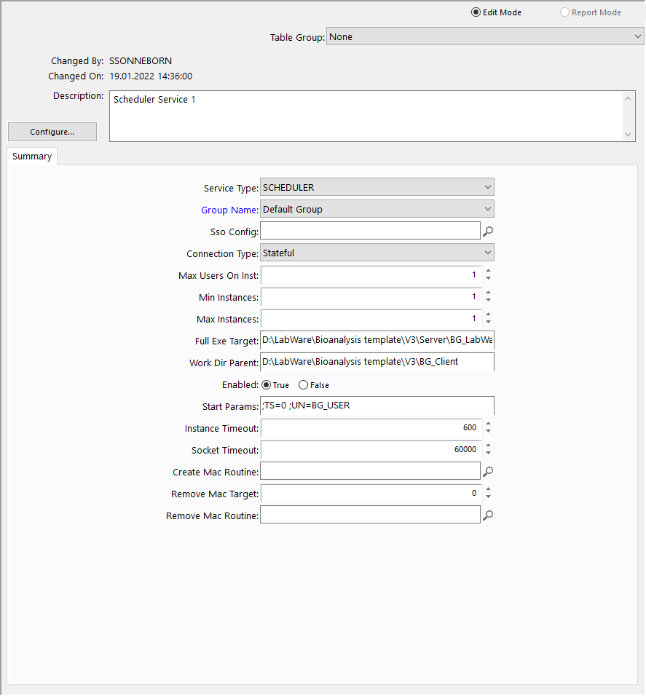
- Make sure the service type is set to SCHEDULER
- Set the Full Exe Target to:
<<Install Directory>>\Server\BG_LabWare.exe
- Set the working directory to:
<<Install Directory>>\Client\BG_Client
- Set the start params: to ; TS = 0; UN = BG_USER
- To configure the cluster manager which will run on the first App server
Menu Configure, Table Manager. Open Table CM Machine and Open Entry MACHINE_1
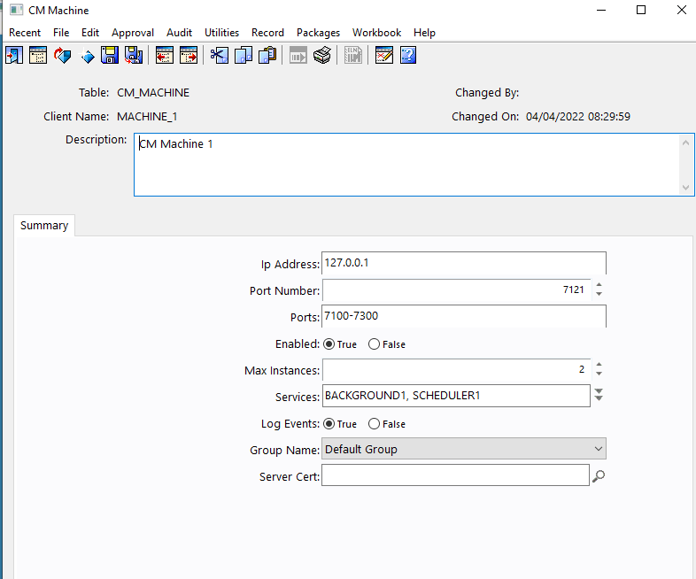

- To configure other cluster managers, use File, Save As to save new records
- For each CM record set the IP address for the relevant server
- Set the Services
- For each CM record set the Port Number and Ports
- For each CM record set the Max instances
- Save the record; File, Save.

Please note that the above screenshot is an example captured during systems development. Please use this as a guide and substitute in the correct strings.

Setting up the Scheduler
Start LIMS using the BG_LabWare shortcut created in Background Service - Configure the database connection and log in.
From the Main Menu, go to Configure | Scheduler | Basic to open the LIMSBasic Scheduler screen.
Set the Cluster Manager Service value to “SCHEDLUER”

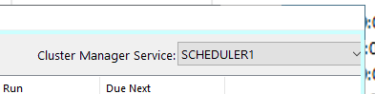

Creating the Windows Service Manager Service
To be performed on the first application server only.

Creating the service with NSSM

Please refer to KT01312 for more updated information on the install and setup.

Restart All Services
To be performed on the application servers.
Verify all installed components:
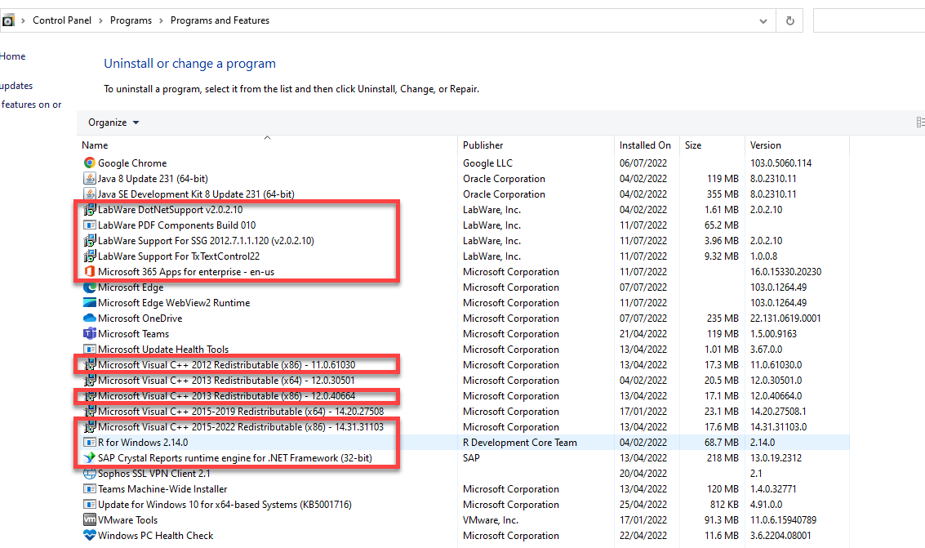

Re-start both Windows Services on the Application server.

Installation Qualification needs to be repeated for each server in each layer.
Execute the database IQ providing evidence for each test step. Any issues to be noted and recorded and the IQ to be signed and reviewed.
Execute the application server IQ on each server providing evidence for each test step. Any issues to be noted and recorded and the IQ to be signed and reviewed.

Appendix A - Environment Descriptions (Configuration Parameters)
This section defines the settings that will change between environments and systems depending on the architecture chosen. The relevant sections for each environment will need to be completed before starting installation so that all the information required is available to complete the installation. Sections in <<chevrons>> need to be changed. Other names are e.g., the database name can also be changed if required.

Database Layer
Define the database name, ODBC connection strings and TNS settings.
Environment | Database/  Schema | Oracle DB SID/  Database Name | ODBC/JDBC connection | TNS Entry
DEV | LBWDEV/  LW_DEV_ADMIN | LBWDEV | LW_DEV_ADMIN@//labwareDATABASE:1522/LBWDEV | LBWDEV =  (DESCRIPTION =  (ADDRESS = (PROTOCOL = TCP)(HOST = labwareDATABASE)(PORT = 1522))  (CONNECT_DATA =  (SERVER = DEDICATED)  (SERVICE_NAME = LBWDEV)  )  )
VAL | LBWVAL/  LW_VAL_ADMIN | LBWVAL | LW_VAL_ADMIN@//labwareDATABASE:1522/LBWVAL | LBWVAL =  (DESCRIPTION =  (ADDRESS = (PROTOCOL = TCP)(HOST = labwareDATABASE)(PORT = 1522))  (CONNECT_DATA =  (SERVER = DEDICATED)  (SERVICE_NAME = LBWVAL)  )  )
PROD | LBWPROD/  LW_PROD_ADMIN | LBWPROD | LW_PROD_ADMIN@//labwareDATABASE:1523/LBWPRDPOM | LBWPROD =  (DESCRIPTION =  (ADDRESS = (PROTOCOL = TCP)(HOST = labwareDATABASE)(PORT = 1523))  (CONNECT_DATA =  (SERVER = DEDICATED)  (SERVICE_NAME = LBWPRDPOM)  )  )

Virtual/Remote Servers and Application Server
Define the LabWare installation location and share name.
Environment | Server Name | Installation Directory | ODBC DSN | Share Name
DEV | W19IT9-LBWDEV  10.100.240.2 | C:\Labware_8 | LBW_DEV | LBW_DEV$
VAL | W19IT9-LBWVAL  10.100.240.3 | C:\LabWare_8 | LBW_VAL | LBW_VAL$
PROD | W19IT9-LBWPROD  10.100.240.4 | C:\LabWare_8 | LBW_PROD | LBW_PROD$

Cluster Manager
(Not required if not using a web client or web services)
NOTE: 1 core in a server can handle 3- 6 LW processes. Each LW instance takes approximately 100KB of memory per instance, if each server is sized for a maximum of 25 instances, this would give a memory requirement of about 2.5GB and processor requirement 4-8 cores.
Define the machine name, instances, port and port range. Note that different port numbers should be used in each environment.
Environment | Server | IP Address | CM  Machine | Port | Ports | Max. Instances | Services | Windows Service Name | Windows Service Description
DEV | W19IT9-LBWDEV | 10.100.240.2 | MACHINE_1 | 7121 | 7100-7300 | 3 | BACKGROUND1  SCHEDULER1 | BGSERVER_LWDEV | Background server for LWDEV
VAL | W19IT9-LBWVAL | 10.100.240.3 | MACHINE_1 | 7121 | 7100-7300 | 3 | BACKGROUND1  SCHEDULER1 | BGSVR_LBWVAL | Background server for LBWVAL
PROD | W19IT9-LBWPROD | 10.100.240.4 | MACHINE_1 | 7121 | 7100-7300 | 3 | BACKGROUND1  SCHEDULER1 | BGSVR_LBWPROD | Background server for LWPROD

Cluster Manager Services
(Not required if not using a web client or web services)
Define the min and max instances. Minimum should always be 1 less than maximum and number of users should always be 1.
Environment | Service | Max Users | Min Instances | Max Instances | Start Params | Instance Timeout | Socket Timeout
DEV | BACKGROUND1 | 3 | 1 | 3 | ;TS=0 ;UN=BG_USER | 600 | 60000
DEV | SCHEDULER1 | 1 | 1 | 1 | ;TS=0 ;UN=SCHEDULER | 600 | 60000
VAL | BACKGROUND1 | 3 | 1 | 3 | ;TS=0 ;UN=BG_USER | 600 | 60000
VAL | SCHEDULER1 | 1 | 1 | 1 | ;TS=0 ;UN=SCHEDULER | 600 | 60000
PROD | BACKGROUND1 | 3 | 1 | 3 | ;TS=0 ;UN=BG_USER | 600 | 60000
PROD | SCHEDULER1 | 1 | 1 | 1 | ;TS=0 ;UN=SCHEDULER | 600 | 60000

Appendix B – Database Installation Log
The Installation Log should be completed for every required step at the point of installation.
In the evidence column you should only add a reference to an attachment.

Step  No | Step | Date executed | Pass/Fail | Signature | Evidence
1 | Run LW_TABLES.SQL
2 | Run LW_INDEX.SQL
3 | Run LW_VIEWS.SQL
4 | Grant access to database users
5 | Copy data
6 | Database Clean-up – Optional

Appendix C – Application Installation Log
The Installation Log should be completed for every required step at the point of installation.
In the evidence column you should only add a reference to an attachment.
Step No | Step | Date executed | Pass/Fail | Signature | Evidence
 | LabWare Installation
 | Configure Microsoft DEP
 | DotNet Support
 | SSG Support
 | Crystal Reports Run Time
 | PDF Enhancements
 | Txt Control
 | Server and Client Setup
 | Application Shortcut
 | Creating the ODBC Data Source Name
 | Server Connection to the Database
 | External Link Directories
 | LIMS Constants
 | Update Crystal Reports
 | LDAP
 | Remote/Virtual Desktop Setup
 | Configuring Service Manager in the Database
 | Configuring Background Services in the Database
 | Creating the Windows Service Manager Service
 | Creating the service with NSSM
 | Restart All Services

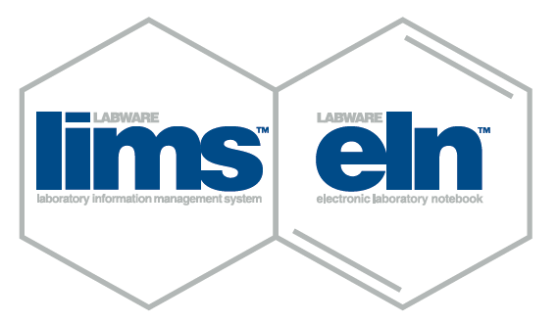

Regional Offices:
Beijing, China · Helsingborg, Sweden · Kolkata, India · Lausanne, Switzerland · Paris, France· Shanghai, China · Singapore · Tokyo, Japan · Verona, Italy · Weinheim, Germany

© LabWare www.labware.com

Corporate Headquarters:

LabWare, Inc.
Three Mill Road, Suite 102, Wilmington, DE 19806
United States
Phone: 302.658.8444
Fax: 302.658.7894
Email: info@labware.com

Offices worldwide
supporting customers
in more than 90 countries

Regional Headquarters:
LabWare Africa
Devon House, Hampton Park,
20 Georgian Crescent
Bryanston, South Africa
Phone: +27 11 516 8700
Fax: +27 11 463 5728
Email: info-Africa@labware.com
LabWare Asia Pacific
Level 1, 1013 Whitehorse Road
Box Hill, Victoria, 3128Australia
Phone: +61 (0) 3 9490 7777
Fax: +61 (0) 3 9898 7814
Email: infoAP@labware.com

LabWare Europe, Middle East, & India
Denzell Lodge, Denzell Gardens,
Dunham Road
Altrincham, Cheshire WA14 4QE
United Kingdom
Phone: +44 (0)161 927 5600
Fax: +44 (0)161 927 5601
Email: infoEU@labware.com

LabWare Latin America
Rua Arminda 93 – 4º Andar,
Itaim Bibi
São Paulo – SP - Brazil - 04545-100
Phone: +55 (11) 2931-6969
Fax: +55 (11) 2931-6969
Email: infoLA@labware.com


